Project Report

On

“University Management System”

IITM GROUP OF INSTITUTIONS
Murthal, Haryana Batch(2022-2026)



Under the supervision of : By: Manish Kumar
Mr. Sourav Kumar (22015001025)

CANDIDATE’S DECLARATION

I, Manish Kumar (Roll No. 22015001025), a student of Bachelor of Technology in Computer Science & Engineering at International Institute Of Technology and Management, Murthal, hereby declare that the project entitled “University Management System” is the result of my own bona fide efforts. This work has been executed adhering strictly to engineering ethics and represents my independent research.

I affirm that this project has not been submitted previously for the award of any degree or diploma and does not infringe upon any prior work. All data, designs, and implementations are original to the best of my knowledge. This declaration ensures that the integrity of the academic process is maintained and that the work fulfills the academic requirements of the institution.

Manish Kumar
22015001025

CERTIFICATE

This is to certify that Manish Kumar, B.Tech CSE 7th Semester, International Institute of Technology and Management, Murthal, has completed the project entitled “University Management System” under our supervision. The project involves the development of a desktop application simulating university operations, using JavaFX and MySQL.

The project is submitted in partial fulfillment of the requirements for the award of the degree of Bachelor of Technology in Computer Science & Engineering. The undersigned acknowledge the completion and submission of this work for academic evaluation. Approval does not imply any endorsement of opinions or conclusions, but solely certifies fulfillment of project requirements.

Signature of Supervisor Signature of H.O.D External

--------------- -------------- -----------
Mr. Vimlesh Sir Mr. Sourav Sir Examiner

ACKNOWLEDGEMENT

I extend my heartfelt gratitude to everyone who guided and supported me throughout this project journey.

Special thanks to Mr. Sourav Sir for his invaluable guidance, insights, and encouragement. I am grateful to my institution, training in-charge, and mentor for providing a platform to practically implement theoretical concepts.

I also thank my friends and family for their continuous support and motivation, and I offer my thanks to The Supreme God Krishn for giving me strength and perseverance. This project represents a significant milestone in my academic and professional development. I am committed to leveraging the knowledge gained and continuously improving my skills to achieve future career objectives.

Group Members:
- Manish Kumar (22015001025)
- Mohammad Kashim (22015001030)
- Shreyansh Sahil (22015001053)
- Gaurav Kumar (22015001021)

ABSTRACT

The University Management System (UMS) is a robust desktop application designed to streamline administrative and academic processes within universities. Built using JavaFX for the front end and MySQL for backend storage, the system simulates essential university functionalities such as login, signup, password recovery, role-based dashboards, attendance management, faculty management, fee processing, and notifications.

The application features a modern GUI with animations, role-based access control, secure session management, and a scalable database structure. It provides Admin, Faculty, Staff, and Student dashboards, each tailored to specific operational needs, ensuring efficient task management.

UMS demonstrates how object-oriented programming principles and secure database interactions can be leveraged to design enterprise-grade applications. Future enhancements include improving responsiveness for multiple screen sizes, modularizing the codebase, and integrating additional features for enhanced usability.
Key Technologies:
- JavaFX – Desktop GUI framework
- FXML – UI layout and design
- MySQL – Relational database management
- Maven – Project and dependency management

GitHub Repository: https://github.com/manishrnl/complete_university_management_system.git

INDEX (TABLE OF CONTENTS)
- Introduction
  - 1.1 Objective of the System
  - 1.2 Justification and Need
  - 1.3 Advantages of the System

- Requirement Analysis
  - 2.1 Functional Requirements
  - 2.2 User Requirements
  - 2.3 Final Requirements

- Design of the System
  - 3.1 Software and Hardware Requirements
  - 3.2 Design Requirements
  - 3.3 Data Flow Diagram (DFD) (Conceptual Description)

- Implementation & Coding
  - 4.1 Operating System
  - 4.2 Languages Used
  - 4.3 Key Features

- System Structure
  - 5.1 Backend
  - 5.2 Frontend

- Project Overview

- Features

- Testing & Test Results
  - 8.1 Testing Objectives
  - 8.2 Test Cases (Examples)

- About the Developer

- Conclusion and Future Scope
  - 10.1 Conclusion
  - 10.2 Future Scope

- Bibliography

1. Introduction

🎯 1.1 Objective of the System
The primary objective of the Complete University Management System (GitHub Repository) is to deliver a robust, feature-rich desktop application for managing core university operations electronically. The system centralizes student, faculty, course, and financial data, enhancing administrative efficiency, accessibility, and security.It contains about 30,000 lines and took about 3 rigorous month to complete

Key Objectives:
- 🗂 Centralized and role-based management of university operations, including student enrollment, course allocation, faculty management, and fee processing.
- 💻 Interactive and modern GUI built with JavaFX, offering visually appealing components, 3D animations, and responsive design tailored for desktop applications.
- 🔐 Secure authentication, password management, and session handling for multiple roles (Admin, Faculty, Student).
- 🗄 Scalable backend integration with MySQL for persistent and secure data storage.

📝 1.2 Justification and Need
The system replaces outdated manual or fragmented university processes with a modern, integrated solution. By leveraging JavaFX for the GUI and MySQL for data management, the system ensures improved usability, faster operations, and real-time access to information. The modular design allows future enhancements, including multi-platform support and additional analytics features.

⭐ 1.3 Advantages of the System
- 🗃 Centralized Data Storage: All university-related information is stored securely in a unified MySQL database.
- 🎨 User-Friendly Interface: JavaFX UI with dynamic alerts, animations, and intuitive navigation.
- 🔑 Role-Based Access Control: Secure login ensures that Administrators, Faculty, and Students access only the relevant modules.
- 📊 Comprehensive Dashboards: Admins can monitor metrics such as student performance, attendance, fee collection, and faculty workload.
- 🛡 Security & Session Management: Includes password recovery, session tracking, and secure credential validation.

📂 2. Requirement Analysis

🔧 2.1 Functional Requirements
- 🔒 Authentication: Secure login with role-based access and password management.
- 👤 User Management: CRUD operations for student and faculty data (Admin).
- 📚 Course Management: Add, update, delete courses, and assign faculty.
- 🏫 Academic Records: Manage examination marks, attendance, and progress reports.
- 💰 Fee Management: Record tuition payments, generate invoices, and maintain fee structures.
- 🔔 Notifications & Alerts: Real-time updates for deadlines, announcements, and pending tasks.
- 📈 Dashboard Views: Separate dashboards for Admin, Faculty, and Students with role-specific information.

👥 2.2 User Requirements
- Administrator: Full access for management, monitoring, and reporting.
- Faculty/Teacher: Manage attendance, submit grades, and interact with students.
- Student: Read-only access to personal info, course schedules, grades, attendance, and fees.

2.3 Final Requirements
- 💻 Cross-platform desktop application built with JavaFX.
- ⚙ Modular and scalable architecture using MVC pattern.
- 🗄 Secure database integration (MySQL).
- 🎨 Engaging, modern UI with animations and responsive components.
- 🔐 Efficient session management and password recovery mechanisms.

🖥 3. Design of the System

🛠 3.1 Software and Hardware Requirements

Software:
- Java 11+ JDK & JavaFX SDK
- MySQL 5.7+ for database
- JDBC with MySQL Connector/J
- IDE: IntelliJ IDEA / Eclipse / NetBeans
- Scene Builder for FXML layout design

Hardware:
- Minimum 4 GB RAM
- Dual-core CPU
- ~10 GB free disk space

🏗 3.2 Design Requirements

MVC Architecture:
- Model: Data objects + database logic
- View: FXML + CSS for UI
- Controller: Event-handling and application logic
Benefits: High modularity, maintainability, and ease of feature expansion.
FXML & CSS:
- UI defined in FXML (Scene Builder)
- Styling via CSS for consistent look and feel

🔄 3.3 Data Flow Diagram (DFD)
The system follows a client-server flow:
- User Input (View): Users interact with the GUI.
- Controller Action: Event-handling code processes input.
- Database Interaction (Model): JDBC communicates with MySQL.
- Data Retrieval: Results returned from database.
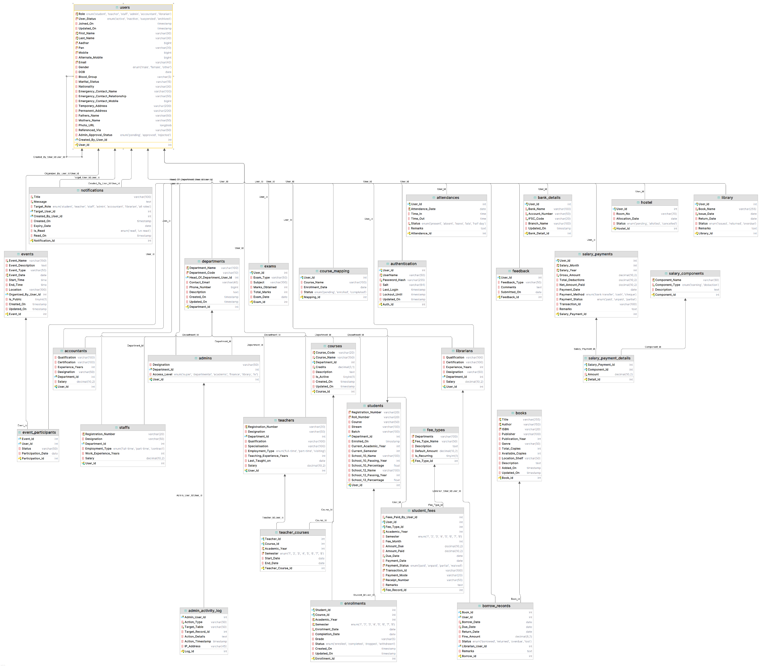
- View Update: UI updated based on retrieved data.
4.Implementation & Coding

4.1 🖥️ Operating System
The Complete University Management System is implemented in Java, making it platform-independent. It can run on major operating systems (Windows, macOS, Linux) with a compatible Java Runtime Environment (JRE) installed. The UI is built using JavaFX, a modern toolkit for rich client applications. The same JavaFX binary executes across different OSes, leveraging OpenJFX libraries (openjfx.io).

4.2 💻 Languages Used
- ☕ Java: Core application logic and controller code (Java 8+).
- JavaFX & FXML: UI layouts are defined in FXML (editable via Scene Builder), styled using CSS.
- 🗄️ SQL (MySQL): Stores application data; connected via JDBC using MySQL Connector/J.
- 🎨 CSS: Custom stylesheets for consistent UI design in JavaFX.

4.3 🌟 Key Features
- 👨‍💼 Admin Dashboard: Manage users, courses, and fees; view and update credit-hour rates.
- 🎓 Student Module: Course registration, profile management, attendance and fee viewing, academic marks.
- 🖼️🧑‍🏫 Teacher Module: Faculty registration, profile updates, attendance marking, grade submission.
- 📊 Attendance System: Daily and semester-wise attendance tracking for students and faculty.
- 📝 Examination & Grading: Input and review assignment, quiz, and exam grades.
- 4.4 🔗 GitHub Repository
- Project code and documentation are available at:
https://github.com/manishrnl/complete_university_management_system.git

5.Bash Diagram
📁 complete_university_management_system
├── 📁 Bundled Software/
│ ├── ⚙️ Complete_UMS.exe
│ ├── ☕ Complete_UMS.jar
│ └── 📖 README.md
├── 📁 Libraries used in Project/
│ ├── ☕ commons-compress-1.26.0.jar
│ ├── ☕ commons-lang3-3.12.0.jar
│ ├── ☕ controlsfx-8.40.11.jar
│ ├── ☕ fontawesomefx-8.9.jar
│ ├── ☕ fontawesomefx-commons-8.15.jar
│ ├── ☕ fontawesomefx-controls-8.15.jar
│ ├── ☕ fontawesomefx-emojione-2.2.7-2.jar
│ ├── ☕ fontawesomefx-fontawesome-4.7.0-5.jar
│ ├── ☕ fontawesomefx-glyphsbrowser-1.3.0.jar
│ ├── ☕ fontawesomefx-icons525-3.0.0-4.jar
│ ├── ☕ fontawesomefx-materialdesignfont-1.7.22-4.jar
│ ├── ☕ fontawesomefx-materialicons-2.2.0-5.jar
│ ├── ☕ fontawesomefx-octicons-4.3.0-5.jar
│ ├── ☕ fontawesomefx-weathericons-2.0.10-5.jar
│ ├── ☕ jcalendar-0.8.1.jar
│ ├── ☕ jcalendar-tz-1.3.3-4.jar
│ ├── ☕ mysql-connector-java-8.0.28.jar
│ ├── ☕ poi-5.1.0.jar
│ ├── ☕ poi-examples-5.1.0.jar
│ ├── ☕ poi-excelant-5.1.0.jar
│ ├── ☕ poi-javadoc-5.1.0.jar
│ ├── ☕ poi-ooxml-5.1.0.jar
│ ├── ☕ poi-ooxml-full-5.1.0.jar
│ ├── ☕ xmlbeans-3.1.0.jar
│ └── ☕ xmlbeans-5.1.1.jar
│
├── 📁 ScreenShot/
│ ├──  adminDashboard.png
│ ├── changePassword.png
│ ├── faculty.png
│ ├── fees.png
│ ├── forgetPassword.png
│ ├── login.png
│ ├── markAttendance.png
│ ├── notifications.png
│ ├── profileView.png
│ ├── result.png
│ ├── salaryDistribution.png
│ ├── signup.png
│ ├── staffsDashboard.png
│ ├── studentsDashboard.png
│ └── viewAttendance.png
├── 📁 src/
│ └── 📁 main/
│ ├── 📁 java/
│ │ ├── ☕ module-info.java
│ │ └── 📁 org/
│ │ └── 📁 example/
│ │ └── 📁 complete_ums/
│ │ ├── 🔒 ChangePassword.java
│ │ ├── 🔓 ChangePasswordWithoutLoggingIn.java
│ │ ├── 🗓️ Events.java
│ │ ├── 🔑 ForgetPassword_Controller.java
│ │ ├── ➕ InsertMissingFieldsIntoSQLTable.java
│ │ ├── 🚪 Login_Controller.java
│ │ ├── 🚀 Main_Application.java
│ │ ├── 📝 MarkAttendance.java
│ │ ├── 🔔 Notification_Controller.java
│ │ ├── 💰 SalaryDistributionController.java
│ │ ├── 📄 Total lines Count.txt
│ │ ├── 📝 Signup_Controller.java
│ │ ├── 👁️ ViewAttendance.java
│ │ ├── 👁️ ViewSalary.java
│ │ ├── 📁 Accountants/
│ │ │ ├── ☕ AccountantController.java
│ │ │ ├── ☕ AccountantsDashboardContent.java
│ │ │ ├── ☕ AccountantsProfileView.java
│ │ │ └── ☕ FeesCollection.java
│ │ ├── 📁 Admin/
│ │ │ ├── 👨‍💼 AccountantManagement.java
│ │ │ ├── ☕ AdminController.java
│ │ │ ├── ☕ TeachersContentsController.java
│ │ │ ├── 👨‍💼 AdminManagement.java
│ │ │ ├── 👤 AdminProfileView.java
│ │ │ ├── 📚 Courses.java
│ │ │ ├── 📜 Exams.java
│ │ │ ├── 🧑‍🏫 Faculty.java
│ │ │ ├── 💬 Feedback.java
│ │ │ ├── 💸 Finance.java
│ │ │ ├── 👷 GroundStaffManagement.java
│ │ │ ├── 🏠 Hostel.java
│ │ │ ├── 📖 LibrariansManagement.java
│ │ │ ├── 🏛️ Library.java
│ │ │ ├── ⚙️ Logs.java
│ │ │ ├── 🔧 Settings.java
│ │ │ ├── 🧑‍🎓 StudentManagement.java
│ │ │ └── 🧑‍🏫 TeacherManagement.java
│ │ ├── 📁 CommonTable/
│ │ │ ├── ☕ AdminLogsTable.java
│ │ │ ├── ☕ AttendanceTable.java
│ │ │ ├── ☕ BorrowedBooksTable.java
│ │ │ ├── ☕ Employee.java
│ │ │ ├── ☕ EventListView.java
│ │ │ ├── ☕ ExamsTable.java
│ │ │ ├── ☕ FacultyMember.java
│ │ │ ├── ☕ Fee_Collection_Table.java
│ │ │ ├── ☕ Fee_Collection_Table_Searching.java
│ │ │ ├── ☕ FinanceFeeTable.java
│ │ │ ├── ☕ GroundStaffTable.java
│ │ │ ├── ☕ LibrariansTable.java
│ │ │ ├── ☕ Manage_Students_Table.java
│ │ │ ├── ☕ NotificationsTable.java
│ │ │ ├── ☕ ResultsTable.java
│ │ │ ├── ☕ SalaryComponent.java
│ │ │ ├── ☕ SalaryComponentLoader.java
│ │ │ ├── ☕ SalaryDistributionTable.java
│ │ │ ├── ☕ SalaryTable.java
│ │ │ ├── ☕ TeacherTable.java
│ │ │ └── ☕ ViewOrReturnBooksTable.java
│ │ ├── 📁 Databases/
│ │ │ ├── 📜 AdminActivityLogs.java
│ │ │ ├── 🔑 AuthenticationSQLQuery.java
│ │ │ ├── 💾 DatabaseConnection.java
│ │ │ ├── 📄 ResultSetProcessor.java
│ │ │ ├── 👤 User.java
│ │ │ ├── 👩‍💻 UserService.java
│ │ │ └── 🔑 UsersSQLQuery.java
│ │ ├── 📁 Java_StyleSheet/
│ │ │ ├── 🎨 Button3DEffect.java
│ │ │ ├── 🎨 Change_Frame_Size.java
│ │ │ ├── 🎨 EdgeColorAnimation.java
│ │ │ ├── 🎨 RoundedImage.java
│ │ │ └── 🎨 Theme_Manager.java
│ │ ├── 📁 Librarians/
│ │ │ ├── 📚 AddBooks.java
│ │ │ ├── 📖 IssueBooks.java
│ │ │ ├── ☕ LibrarianController.java
│ │ │ ├── ☕ LibrariansDashboardContent.java
│ │ │ ├── 👤 LibrariansProfileView.java
│ │ │ ├── ✏️ UpdateBooks.java
│ │ │ └── 📖 ViewOrReturnBooks.java
│ │ ├── 📁 Staffs/
│ │ │ ├── ☕ StaffsController.java
│ │ │ ├── ☕ StaffsDashboardContent.java
│ │ │ └── 👤 StaffsProfileView.java
│ │ ├── 📁 Students/
│ │ │ ├── 📜 Exams.java
│ │ │ ├── 💸 Finance.java
│ │ │ ├── 🚌 HostelTransport.java
│ │ │ ├── 🏛️ Library.java
│ │ │ ├── ☕ StudentsController.java
│ │ │ ├── ☕ StudentsDashboardContent.java
│ │ │ ├── 👤 StudentsProfile.java
│ │ │ ├── 🗓️ TimeTable.java
│ │ │ └── 📖 ViewIssuedBooks.java
│ │ ├── 📁 Teachers/
│ │ │ └── ☕ TeacherController.java
│ │ │ └── ☕ TeachersContentsController.java
│ │ │ └── 👤 ViewTeachersProfile.java
│ │ └── 📁 ToolsClasses/
│ │ ├── 🔔 AlertManager.java
│ │ ├── ⚙️ AppProperties.java
│ │ ├── ⚙️ CustomAlertController.java
│ │ ├── 🖼️ LoadFrame.java
│ │ ├── 🗺️ NavigationManager.java
│ │ ├── 🔑 SessionManager.java
│ │ └── 📜 WrappedTextCellFactory.java
│ └── 📁 resources/
│ ├── ⚙️ application.properties
│ ├── 📁 META-INF/
│ │ └── 📄 MANIFEST.MF
│ ├── 📁 org/
│ │ └── 📁 example/
│ │ └── 📁 complete_ums/
│ │ ├── 🔒 changePassword.fxml
│ │ ├── 🔓 changePasswordWithoutLoggingIn.fxml
│ │ ├── ⚙️ customAlerts.fxml
│ │ ├── 🗓️ Events.fxml
│ │ ├── 🔑 ForgetPassword.fxml
│ │ ├── ➕ InsertMissingFieldsIntoSQLTable.fxml
│ │ ├── 🚪 Login.fxml
│ │ ├── 📝 MarkAttendance.fxml
│ │ ├── 🔔 Notifications.fxml
│ │ ├── 💰 SalaryDistribution.fxml
│ │ ├── 📝 Signup.fxml
│ │ ├── 👁️ ViewAttendance.fxml
│ │ ├── 👁️ ViewSalary.fxml
│ │ ├── 📁 Accountants/
│ │ │ ├── ☕ AccountantsDashboard.fxml
│ │ │ ├── ☕ AccountantsDashboardContent.fxml
│ │ │ ├── 👤 accountantsProfileView.fxml
│ │ │ └── 💰 feesCollection.fxml
│ │ ├── 📁 Admin/
│ │ │ ├── 👨‍💼 AccountantManagement.fxml
│ │ │ ├── ☕ AdminDashboard.fxml
│ │ │ ├── ☕ TeachersContentsController.fxml
│ │ │ ├── 👨‍💼 AdminManagement.fxml
│ │ │ ├── 👤 AdminProfileView.fxml
│ │ │ ├── 📚 courses.fxml
│ │ │ ├── 📜 exams.fxml
│ │ │ ├── 🧑‍🏫 faculty.fxml
│ │ │ ├── 💬 feedback.fxml
│ │ │ ├── 👷 GroundStaffManagement.fxml
│ │ │ ├── 📖 LibrariansManagement.fxml
│ │ │ ├── ⚙️ logs.fxml
│ │ │ ├── 🔧 settings.fxml
│ │ │ ├── 🧑‍🎓 StudentsManagement.fxml
│ │ │ └── 🧑‍🏫 TeacherManagement.fxml
│ │ ├── 📁 Images/
│ │ │ ├── Arrow Keys.webp
│ │ │ ├── Back.PNG
│ │ │ ├── close.png
│ │ │ ├── confirmation.png
│ │ │ ├── day_night_toggle_theme.jpeg
│ │ │ ├── error.png
│ │ │ ├── Forward.PNG
│ │ │ ├── HidePassword.jpg
│ │ │ ├── info.png
│ │ │ ├── Maximize.png
│ │ │ ├── Minimize.png
│ │ │ ├── password.png
│ │ │ ├── ShowPassword.png
│ │ │ ├── UserName.png
│ │ │ └── warning.png
│ │ ├── 📁 Librarians/
│ │ │ ├── 📚 AddBooks.fxml
│ │ │ ├── 📖 IssueBooks.fxml
│ │ │ ├── 👤 LibrarianProfileView.fxml
│ │ │ ├── ☕ LibrariansDashboard.fxml
│ │ │ ├── ☕ LibrariansDashboardContent.fxml
│ │ │ ├── 💰 SalaryDistribution.fxml
│ │ │ ├── ✏️ UpdateBooks.fxml
│ │ │ └── 📖 ViewOrReturnBooks.fxml
│ │ ├── 📁 Staffs/
│ │ │ ├── ☕ StaffsDashboard.fxml
│ │ │ ├── ☕ StaffsDashboardContent.fxml
│ │ │ └── 👤 StaffsProfileView.fxml
│ │ ├── 📁 Students/
│ │ │ ├── 📜 Exams.fxml
│ │ │ ├── 💸 Finance.fxml
│ │ │ ├── 🚌 HostelTransport.fxml
│ │ │ ├── 🏛️ Library.fxml
│ │ │ ├── ☕ StudentsDashboard.fxml
│ │ │ ├── ☕ StudentsDashboardContent.fxml
│ │ │ ├── 👤 StudentsProfile.fxml
│ │ │ ├── 🗓️ TimeTable.fxml
│ │ │ └── 📖 viewIssuedBooks.fxml
│ │ ├── 📁 Stylesheet/
│ │ │ ├── 🖌️ Custom-Theme.css
│ │ │ ├── 🖌️ Dark_Theme.css
│ │ │ └── 🖌️ Light-Theme.css
│ │ └── 📁 Teachers/
│ │ └── ☕ TeachersDashboardContent.fxml
│ │ └── ☕ TeachersDashboard.fxml
│ │ └── 👤 viewTeachersProfile.fxml
│ └── 📁 sound/
│ ├── 🎵 error.mp3
│ ├── 🎵 hover.mp3
│ └── 🎵 sound2.mp3
├── 💾 DataBase.sql
├── 🚫 .gitignore
├── 📄 DataBase.sql
├── 📖 README.md
├── ⚙️ Save_Themes.properties
├── ⚙️ mvnw
├── ⚙️ mvnw.cmd
├── 📄 pom.xml
└── 📄 push into github.txt

6.System Structure

6.1 🖥️ Backend
The backend is implemented in Java and handles core logic and data management. Key components include:
- ☑ Core Java Classes:
Handles business logic and module operations. Examples:
Dashboard.java, AddStudent.java, CourseManagement.java, FeeStructure.java.
Utility classes include helper methods and input validations.
- ☑ Database Connector (JDBC):
Class Conn.java manages MySQL connections via MySQL Connector/J.
SQL queries are executed through Statement or PreparedStatement objects for CRUD operations. Data flows seamlessly between Java and MySQL.
- ☑ SQL Schema:
MySQL tables include students, faculty, courses, fees, attendance, exam results, etc.
Schema file: DataBase.sql. Ensures referential integrity and correct data types.

6.2 🎨 Frontend
The frontend uses JavaFX and the MVC pattern:
- ☑ FXML Files:
Each screen (login, dashboard, forms, reports) has a corresponding FXML layout using containers like BorderPane, GridPane, etc.
UI components include buttons, text fields, table views, and DatePickers. Edited visually with Scene Builder.
- ☑ Controller Classes:
Example: DashboardController.java, AddStudentController.java.
Handles user actions, validates inputs, and communicates with backend logic and database.
- ☑ UI Controls & Styling:
Uses JavaFX controls: Button, TextField, TableView, DatePicker.
CSS styling ensures polished appearance and responsive layout.

7.Project Overview
The Complete University Management System (CUMS) is a desktop-based solution for centralized university data management. Built using Java, JavaFX, and MySQL, it provides a modern, responsive interface for administrators, faculty, and students.
GitHub Repository: https://github.com/manishrnl/complete_university_management_system.git

Preview of Code
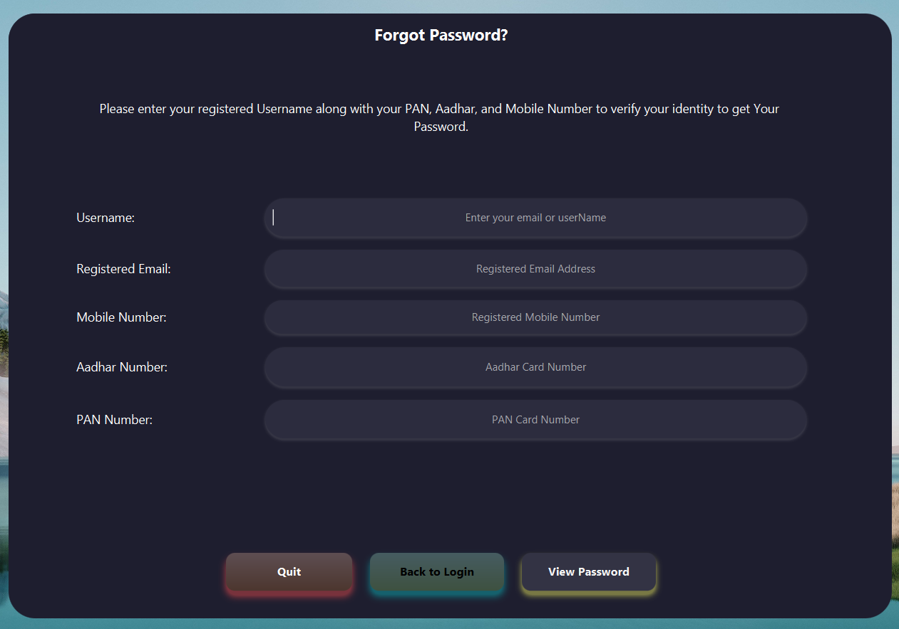
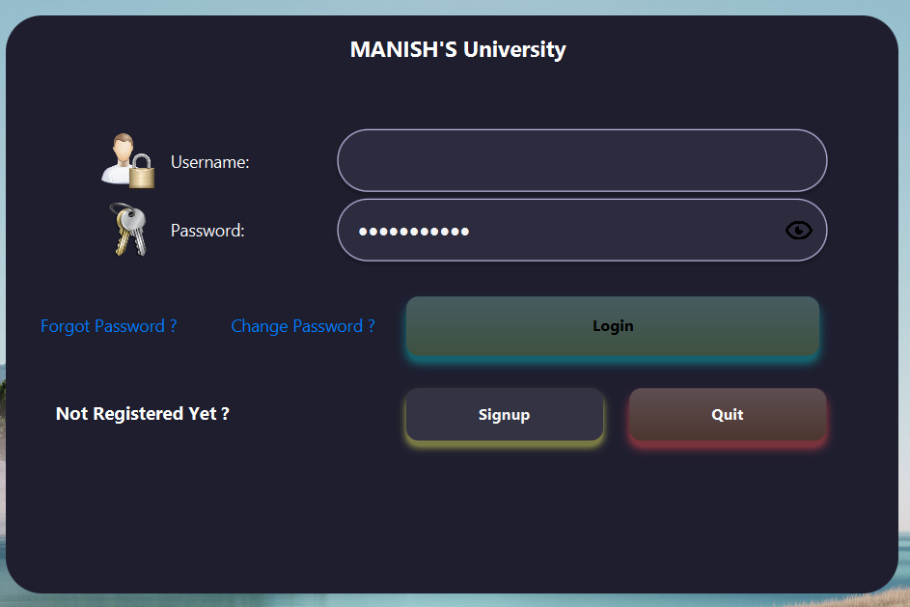

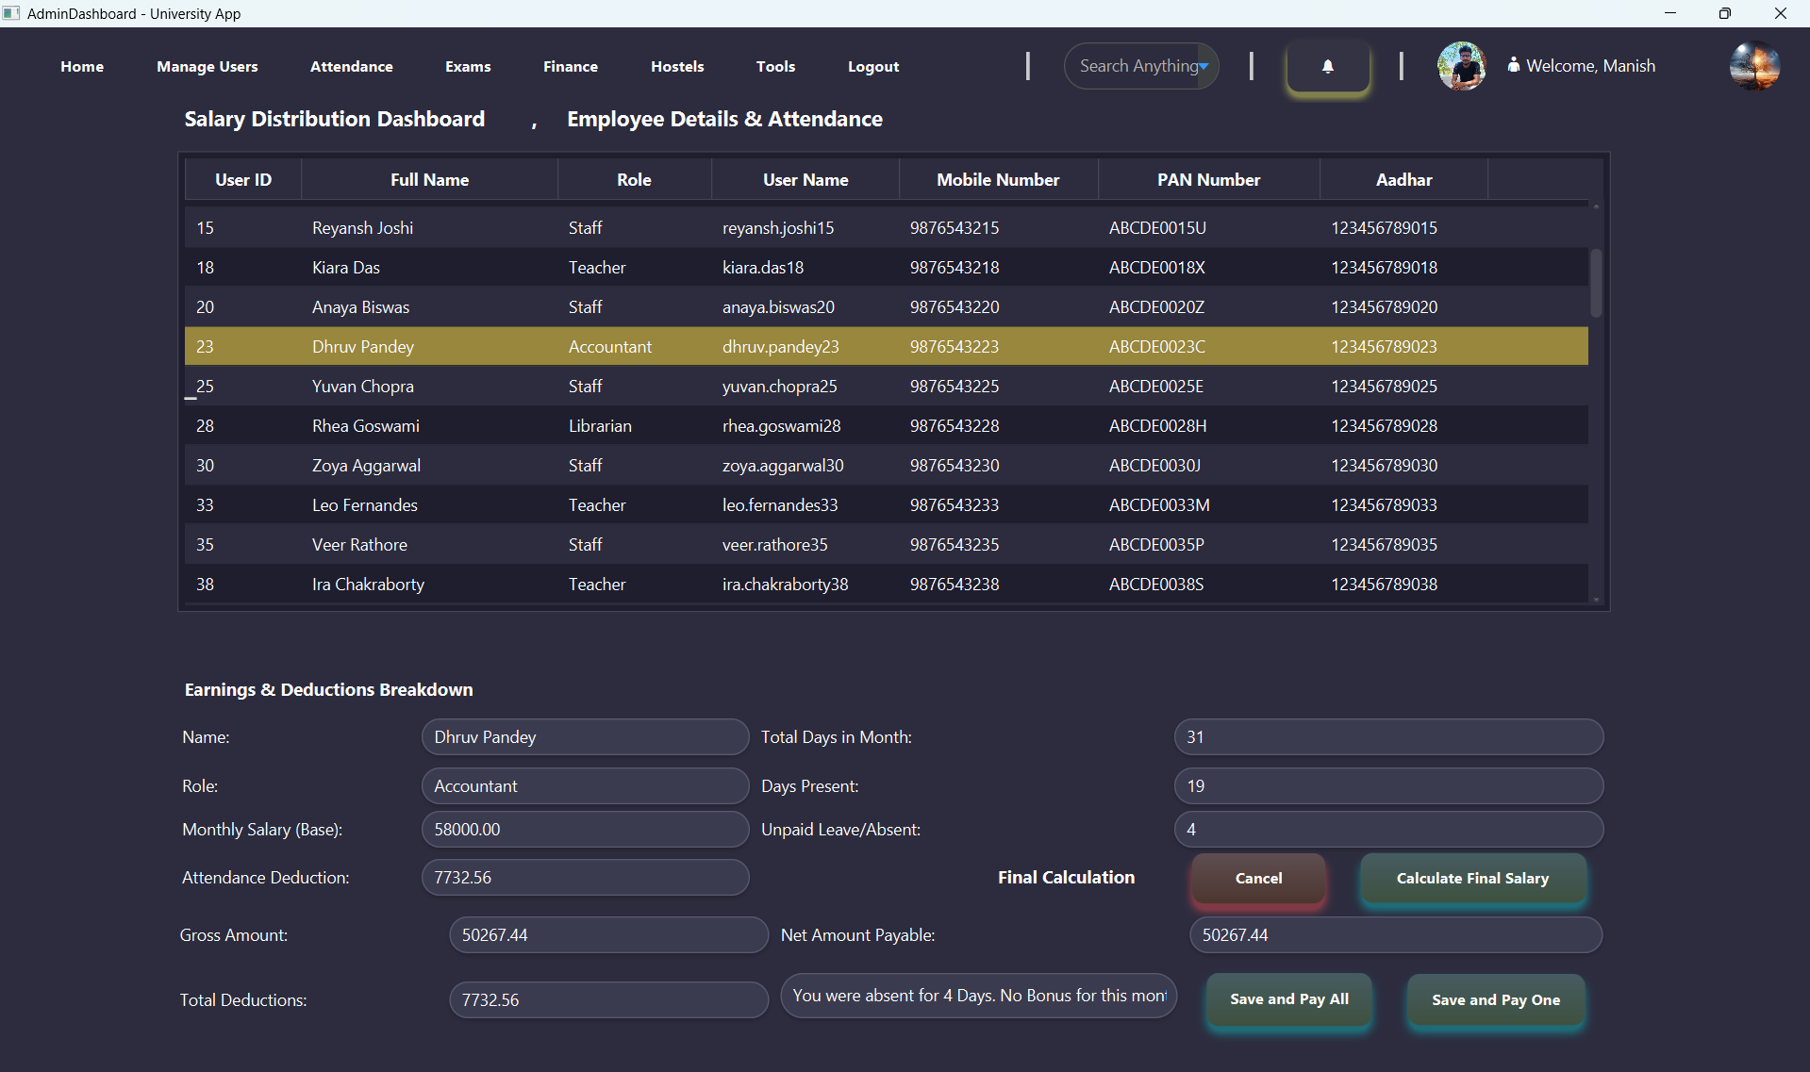
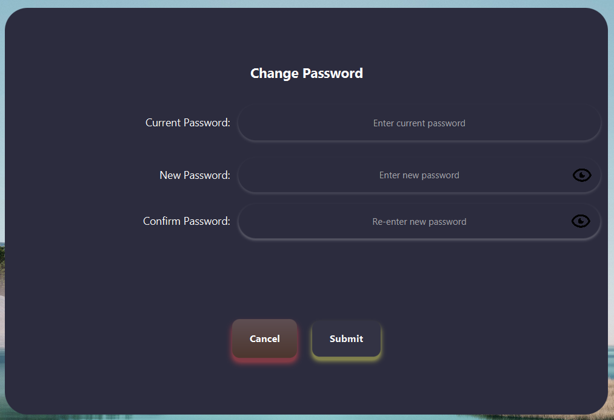
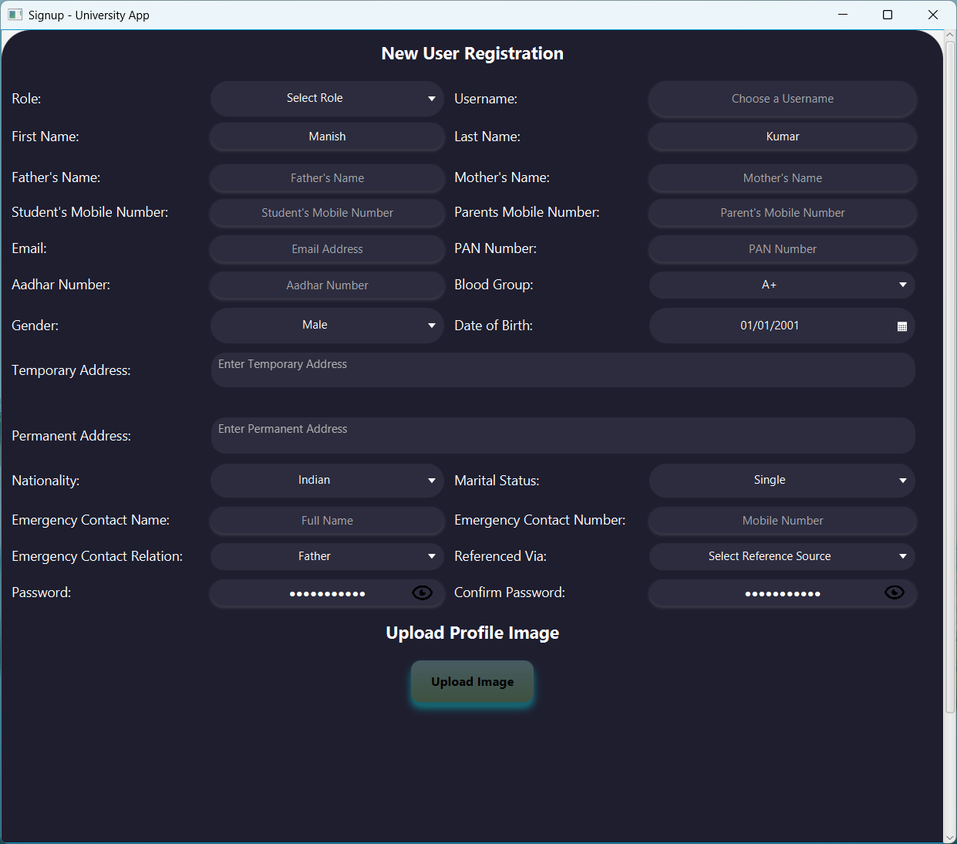
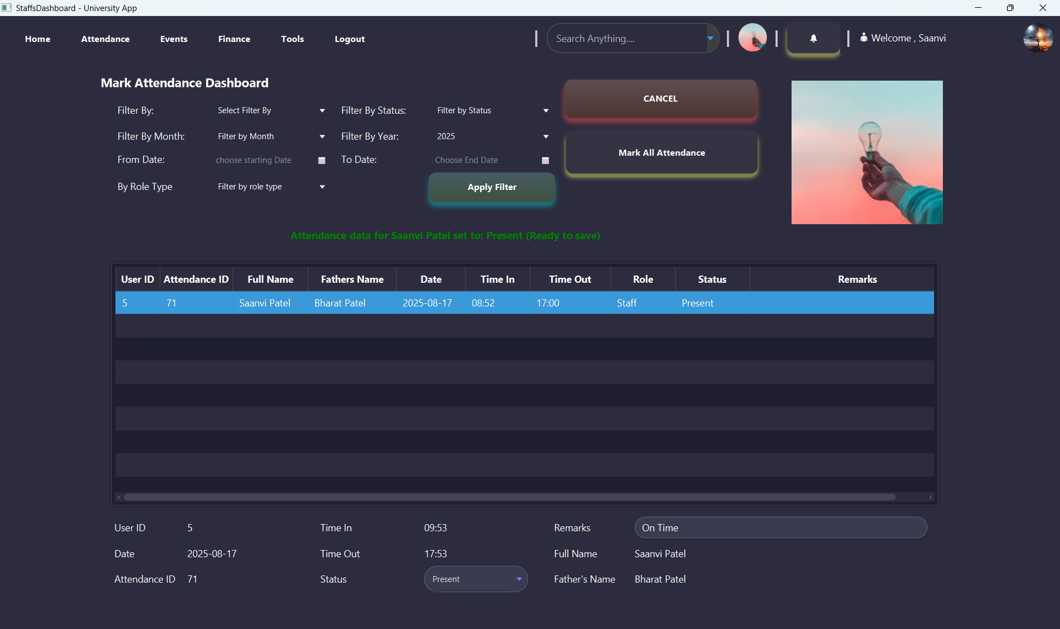

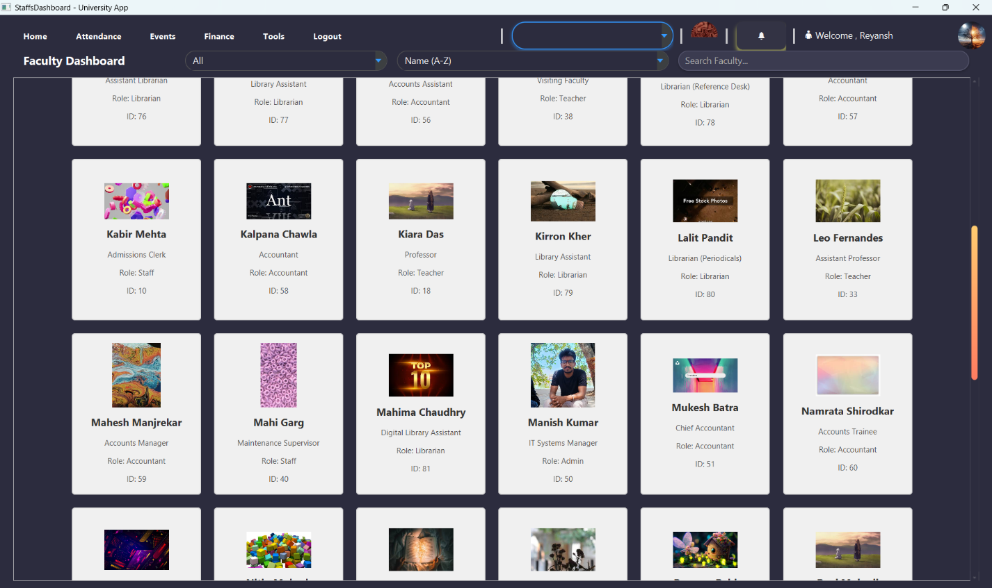
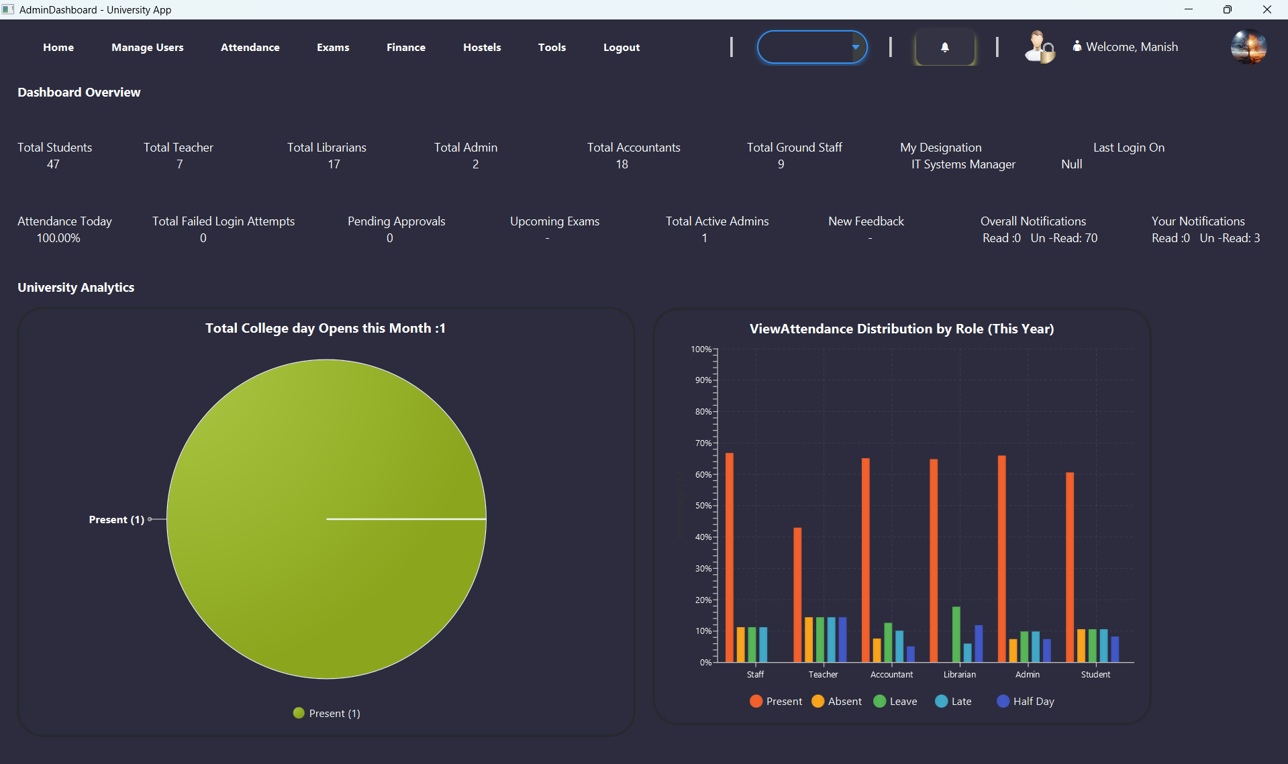
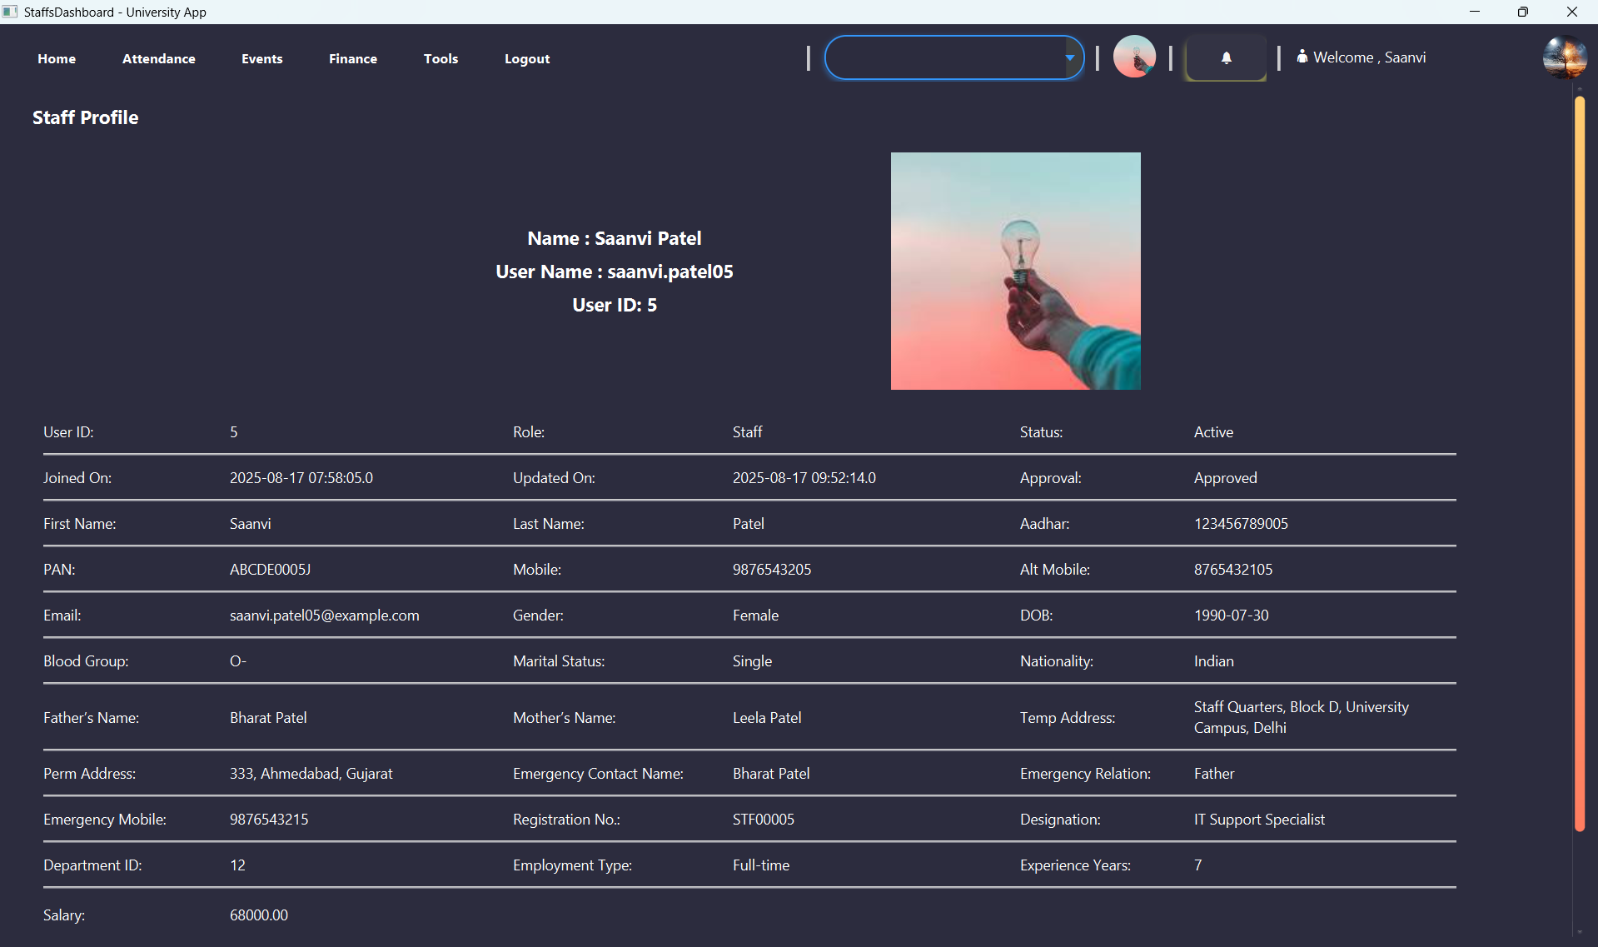
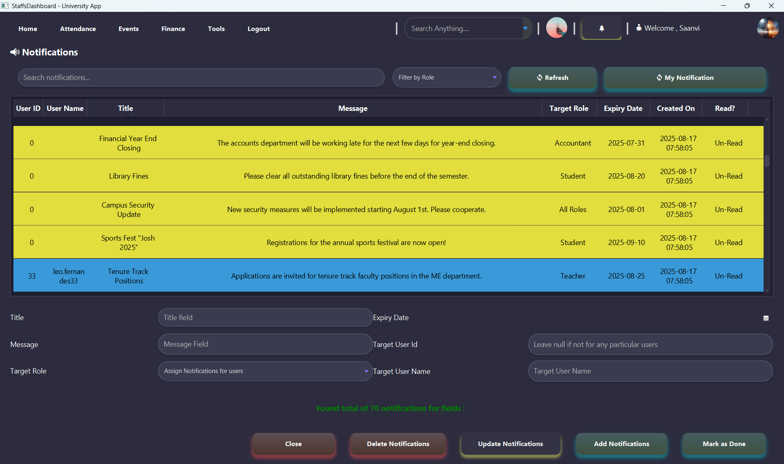
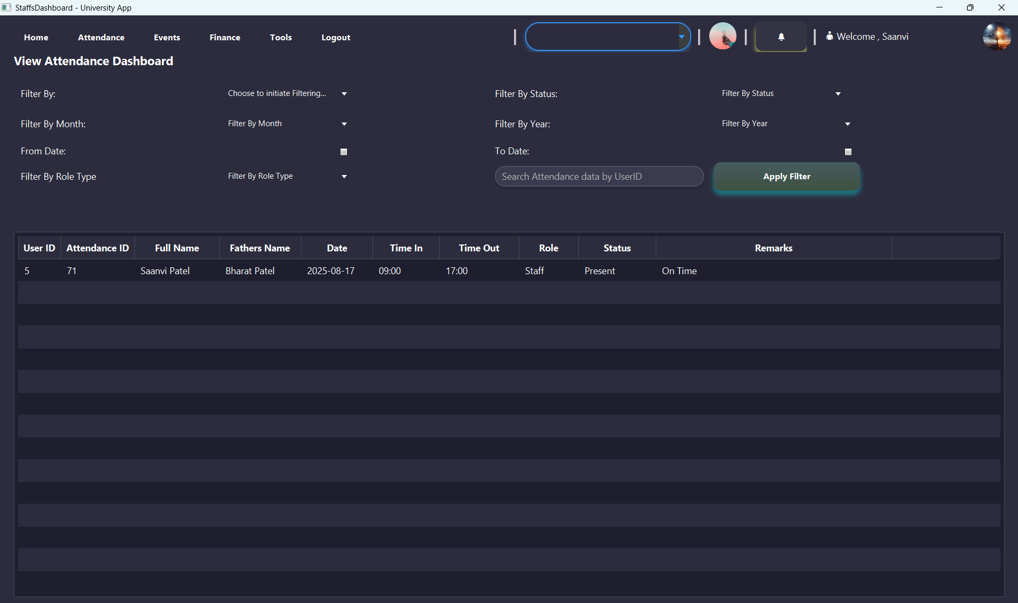
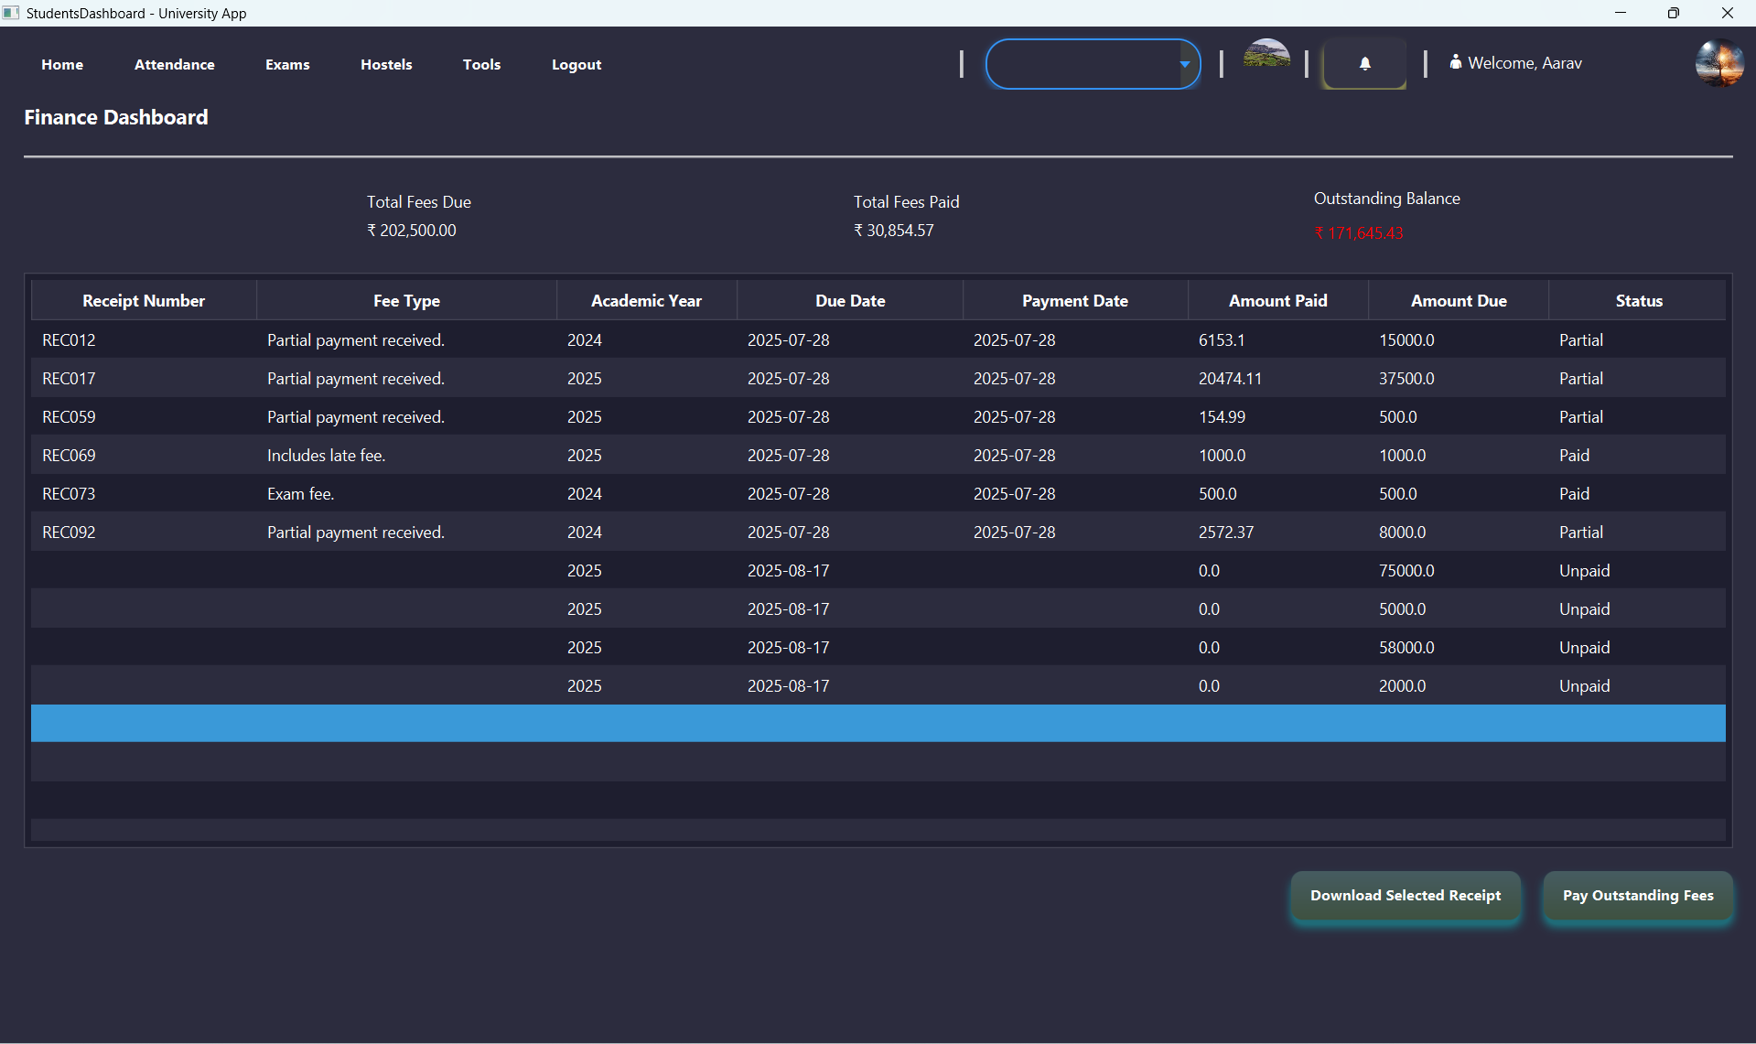

Login.java
public class Login_Controller implements Initializable {
Theme_Manager theme_Manager = new Theme_Manager();
private Button3DEffect button3DEffect = new Button3DEffect();
NavigationManager navigationManager = NavigationManager.getInstance();
LoadFrame loadFrame = new LoadFrame();
SessionManager sessionManager = SessionManager.getInstance();
@FXML
private PasswordField passwordField;
@FXML
private TextField showPasswordField;
@FXML
private ImageView eyeIcon;
private boolean isPasswordVisible = false;
@FXML
private TextField usernameField;
@FXML
private Label errorLabel;
@FXML
private Button LoginButton, SignupButton, quitButton;
private static int passwordCount = 5;
private static final int MAX_ATTEMPTS = 5;
@Override
public void initialize(java.net.URL location, java.util.ResourceBundle resources) {
showPasswordField.textProperty().bindBidirectional(passwordField.textProperty());
LoadFrame.setMessage(errorLabel, "", "GREEN");
passwordCount = MAX_ATTEMPTS;
button3DEffect.applyEffect(quitButton, "/sound/error.mp3");
button3DEffect.applyEffect(LoginButton, "/sound/sound2.mp3");
button3DEffect.applyEffect(SignupButton, "/sound/sound2.mp3");
}
@FXML
private void togglePasswordVisibility() {
isPasswordVisible = !isPasswordVisible;
showPasswordField.setVisible(isPasswordVisible);
showPasswordField.setManaged(isPasswordVisible);
passwordField.setVisible(!isPasswordVisible);
passwordField.setManaged(!isPasswordVisible);
}
@FXML
void handleForgotPassword(ActionEvent event) {
navigationManager.navigateTo("ForgetPassword.fxml");
}
@FXML
void handleSignupButton(ActionEvent event) {
navigationManager.navigateTo("Signup.fxml");
}
private boolean validateUserName(String userName) throws SQLException {
// This is a database operation, so it can stay on the background thread.
String query = "SELECT Lockout_Until FROM Authentication WHERE UserName = ?";
try (Connection connection = DatabaseConnection.getConnection();
PreparedStatement pstmt = connection.prepareStatement(query)) {
pstmt.setString(1, userName);
ResultSet rs = pstmt.executeQuery();
if (rs.next()) {
Timestamp lockoutUntil = rs.getTimestamp("Lockout_Until");
if (lockoutUntil != null && lockoutUntil.toLocalDateTime().isAfter(LocalDateTime.now())) {
LocalDateTime lockoutDateTime = lockoutUntil.toLocalDateTime();
LocalDateTime now = LocalDateTime.now();
Duration duration = Duration.between(now, lockoutDateTime);
long minutes = duration.toMinutes();
DateTimeFormatter formatter = DateTimeFormatter.ofPattern("MMMM d, yyyy");
String formattedDate = lockoutDateTime.toLocalDate().format(formatter);
String errorMessage = "Account is locked for date " + formattedDate +
", Please try again after time - " + minutes + " minutes.";
// IMPORTANT: The UI update needs to be on the FX thread.
Platform.runLater(() -> LoadFrame.setMessage(errorLabel, errorMessage, "RED"));
return false;
}
return true;
} else {
// IMPORTANT: UI update wrapped in Platform.runLater
Platform.runLater(() -> LoadFrame.setMessage(errorLabel, "Invalid Username.", "RED"));
return false;
}
} catch (SQLException e) {
// IMPORTANT: UI update wrapped in Platform.runLater
Platform.runLater(() -> LoadFrame.setMessage(errorLabel, "Database error during username validation: " + e.getMessage(), "RED"));
throw e; // Re-throw the exception to be caught by the calling Task.
}
}
private boolean validatePasswordAndManageAttempts(String userName, String password) throws SQLException {
String query = "SELECT * FROM Authentication WHERE UserName = ? AND Password_Hash = ?";
try (Connection connection = DatabaseConnection.getConnection();
PreparedStatement pstmt = connection.prepareStatement(query)) {
pstmt.setString(1, userName);
pstmt.setString(2, password);
ResultSet rs = pstmt.executeQuery();
if (rs.next()) {
passwordCount = MAX_ATTEMPTS;
clearLockout(userName, connection);
// UI update
Platform.runLater(() -> LoadFrame.setMessage(errorLabel, "Initiating Login Process....", "GREEN"));
return true;
} else {
--passwordCount;
if (passwordCount > 0) {
// UI update
String message = "Password Incorrect. You have " + passwordCount + " attempts left.";
Platform.runLater(() -> LoadFrame.setMessage(errorLabel, message, "RED"));
} else {
setLockout(userName, connection);
// UI update
String message = "You have exhausted all attempts. Your account is locked for 2 hours. Please contact admin to reset your password or try again later.";
Platform.runLater(() -> LoadFrame.setMessage(errorLabel, message, "RED"));
return false;
}
}
return false;
}
}
private StackPane createLoadingOverlay() {
ProgressIndicator pIndicator = new ProgressIndicator();
pIndicator.setPrefSize(80, 80);
pIndicator.setMaxSize(80, 80);
Label startingLabel = new Label("Taking you to your destined Page ... Please wait a moment");
startingLabel.setStyle("-fx-text-fill: white; -fx-font-size: 17px;");
startingLabel.setVisible(false);
VBox content = new VBox(10, pIndicator, startingLabel);
content.setAlignment(Pos.CENTER);
StackPane overlay = new StackPane(content);
overlay.setAlignment(Pos.CENTER);
overlay.setStyle("-fx-background-color: rgba(0, 0, 0, 0.4);");
PauseTransition delay0 = new PauseTransition(javafx.util.Duration.seconds(0));
delay0.setOnFinished(event -> startingLabel.setVisible(true));
delay0.play();
PauseTransition delay1 = new PauseTransition(javafx.util.Duration.seconds(4));
delay1.setOnFinished(event -> startingLabel.setText("Still loading, please wait .We are trying to Load your page sooner..."));
delay1.play();
PauseTransition delay2 = new PauseTransition(javafx.util.Duration.seconds(7));
delay2.setOnFinished(event -> startingLabel.setText("It's taking longer than usual. It might be slow internet connectivity on your side \n or the database I used is responding very late at present."));
delay2.play();
return overlay;
}
private void setLockout(String userName, Connection connection) {
// Schedule UI update on the JavaFX Application Thread
Platform.runLater(() -> {
LoadFrame.setMessage(errorLabel, "Locking user account due to multiple failed attempts...", "RED");
});
String updateQuery = "UPDATE Authentication SET Lockout_Until = ? WHERE UserName = ?";
try (PreparedStatement pstmt = connection.prepareStatement(updateQuery)) {
DateTimeFormatter formatter = DateTimeFormatter.ofPattern("yyyy-MM-dd HH:mm:ss");
String formattedDateTime = LocalDateTime.now().plusHours(2).format(formatter);
pstmt.setString(1, formattedDateTime); // bind as String in correct format
pstmt.setString(2, userName);
pstmt.executeUpdate();
// Schedule UI update on the JavaFX Application Thread
Platform.runLater(() -> {
LoadFrame.setMessage(errorLabel, "Login_Controller: User '" + userName + "' locked out " +
"until " + formattedDateTime, "RED");
});
} catch (SQLException ex) {
// Schedule UI update on the JavaFX Application Thread
Platform.runLater(() -> {
LoadFrame.setMessage(errorLabel, "Error while locking user account: " + ex.getMessage(), "RED");
});
ex.printStackTrace();
}
}
private void clearLockout(String userName, Connection connection) {
// Schedule UI update on the JavaFX Application Thread
Platform.runLater(() -> {
LoadFrame.setMessage(errorLabel, "Clearing user lockout...", "GREEN");
});
String updateQuery = "UPDATE Authentication SET Lockout_Until = NULL WHERE UserName = ?";
try (PreparedStatement pstmt = connection.prepareStatement(updateQuery)) {
pstmt.setString(1, userName);
pstmt.executeUpdate();
} catch (SQLException ex) {
// Schedule UI update on the JavaFX Application Thread
Platform.runLater(() -> {
LoadFrame.setMessage(errorLabel, "Error while clearing user lockout: " + ex.getMessage(), "RED");
});
System.err.println("Login_Controller: Exception while clearing user lockout: " + ex.getMessage());
ex.printStackTrace();
}
}
@FXML
void handleLoginButton(ActionEvent event) {
String userName = usernameField.getText().trim();
String password = passwordField.getText().trim();
if (userName.isEmpty() || password.isEmpty()) {
LoadFrame.setMessage(errorLabel, "All Fields are required.", "RED");
return;
}
// Get the root node so we can add/remove overlay
StackPane rootPane = (StackPane) ((Node) event.getSource()).getScene().getRoot();
StackPane overlay = createLoadingOverlay();
rootPane.getChildren().add(overlay);
Task<Void> loginTask = new Task<>() {
@Override
protected Void call() throws Exception {
// Show first message
Platform.runLater(() -> LoadFrame.setMessage(errorLabel,
"Initiating Login Process... Please wait while we fetch details and validate it for further process....",
"GREEN"));
if (!validateUserName(userName)) return null;
if (!validatePasswordAndManageAttempts(userName, password)) return null;
// Step 3: Fetch user details
String query = """
SELECT a.User_Id, u.Mobile,u.Permanent_Address,u.DOB,a.Password_Hash, u.Role,
u.User_Status, u.Admin_Approval_Status,u.First_Name, u.Aadhar,u.Nationality,
u.Last_Name, u.Email, u.Pan
FROM Authentication a
JOIN Users u ON a.User_Id = u.User_Id
WHERE a.UserName = ?
""";
try (Connection connection = DatabaseConnection.getConnection();
PreparedStatement pstmt = connection.prepareStatement(query)) {
pstmt.setString(1, userName);
ResultSet rs = pstmt.executeQuery();
if (rs.next()) {
Platform.runLater(() -> LoadFrame.setMessage(errorLabel,
"Setting Users Details and Logging you to the main Page", "GREEN"));
int userId = rs.getInt("User_Id");
String dbPassword = rs.getString("Password_Hash");
String role = rs.getString("Role");
String approval = rs.getString("Admin_Approval_Status");
// Approval check
switch (approval) {
case "Rejected" -> {
Platform.runLater(() -> LoadFrame.setMessage(errorLabel,
"Account rejected. Contact admin.", "RED"));
return null;
}
case "Pending" -> {
Platform.runLater(() -> LoadFrame.setMessage(errorLabel,
"Approval pending. Contact admin.", "RED"));
return null;
}
}
// Save in session manager
sessionManager.setUserID(userId);
sessionManager.setUserName(userName);
sessionManager.setPassword(dbPassword);
sessionManager.setFirstName(rs.getString("First_Name"));
sessionManager.setLastName(rs.getString("Last_Name"));
sessionManager.setEmail(rs.getString("Email"));
sessionManager.setPan(rs.getString("Pan"));
sessionManager.setPhone(String.valueOf(rs.getLong("Mobile")));
sessionManager.setAddress(rs.getString("Permanent_Address"));
sessionManager.setDOB(rs.getDate("DOB"));
sessionManager.setRole(role);
sessionManager.setAadhar(rs.getString("Aadhar"));
sessionManager.setCountry(rs.getString("Nationality"));
// Role-based navigation
String fxmlPath = switch (role) {
case "Student" -> "Students/StudentsDashboard.fxml";
case "Admin" -> "Admin/AdminDashboard.fxml";
case "Teacher" -> "Teachers/TeachersDashboard.fxml";
case "Staff" -> "Staffs/StaffsDashboard.fxml";
case "Accountant" -> "Accountants/AccountantsDashboard.fxml";
case "Librarian" -> "Librarians/LibrariansDashboard.fxml";
default -> null;
};
if (fxmlPath != null) {
setUserStatus(userId);
String finalPath = fxmlPath;
Platform.runLater(() -> navigationManager.navigateTo(finalPath));
}
} else {
Platform.runLater(() -> LoadFrame.setMessage(errorLabel,
"Invalid credentials. Check at Login_Controller.handleLoginButton() manually.", "RED"));
}
} catch (SQLException e) {
Platform.runLater(() -> LoadFrame.setMessage(errorLabel,
"SQL error at Login_Controller.handleLoginButton(): " + e.getMessage(), "RED"));
} catch (Exception e) {
Platform.runLater(() -> LoadFrame.setMessage(errorLabel,
"Unexpected error: " + e.getMessage(), "RED"));
}
return null;
}
@Override
protected void succeeded() {
rootPane.getChildren().remove(overlay); // remove loading screen
}
@Override
protected void failed() {
rootPane.getChildren().remove(overlay);
LoadFrame.setMessage(errorLabel, "Login failed. Please try again.", "RED");
}
};
Thread loginThread = new Thread(loginTask);
loginThread.setDaemon(true);
loginThread.start();
}
private void setUserStatus(int userId) throws SQLException {
String query = "Update Users set User_Status ='Active' where User_Id=" + userId;
try (Connection connection = DatabaseConnection.getConnection();
PreparedStatement pstmt = connection.prepareStatement(query)) {
pstmt.executeUpdate();
}
}
public void handleQuit(ActionEvent actionEvent) {
Stage currentStage = (Stage) ((Node) actionEvent.getSource()).getScene().getWindow();
currentStage.close();
}
public void handleChangePassword(ActionEvent actionEvent) {
navigationManager.navigateTo("changePasswordWithoutLoggingIn.fxml");
}
}
Admin Dashboard.java
public class AdminController implements Initializable {
private AdminActivityLogs adminActivityLogs = new AdminActivityLogs();
private Theme_Manager themeManager = new Theme_Manager();
private RoundedImage roundedImage = new RoundedImage();
private Connection connection = DatabaseConnection.getConnection();
private AlertManager alertManager = new AlertManager();
private LoadFrame loadFrame = new LoadFrame();
private SessionManager sessionManager = SessionManager.getInstance();
private Button3DEffect button3DEffect = new Button3DEffect();
private NavigationManager navigationManager = NavigationManager.getInstance();
@FXML
private ComboBox<String> comboSearch;
@FXML
private ImageView lightDarkThemeImage;
@FXML
private Button btnNotifications;
@FXML
private Label menuAdminProfile, errorMessageLabel;
@FXML
private StackPane contentArea;
@FXML
private VBox root;
@FXML
private ImageView profileImage;
private String currentPage = "";
private static AdminController instance;
private File selectedImageFile;
private final Map<String, String> fxmlPathMap = new HashMap<>();
public AdminController() throws SQLException {
instance = this;
}
private final Stack<String> backwardStack = new Stack<>();
private final Stack<String> forwardStack = new Stack<>();
String currentTheme = null;
private final Map<String, String> pageMap = new HashMap<>();
public static AdminController getInstance() {
return instance;
}
private List<String> navigationArrow = new ArrayList<>();
@Override
public void initialize(URL url, ResourceBundle resourceBundle) {
initialisePageMap();
ObservableList<String> items = FXCollections.observableArrayList(pageMap.keySet());
FilteredList<String> filteredItems = new FilteredList<>(items, p -> true);
comboSearch.setEditable(true);
comboSearch.setItems(filteredItems);
// Filter logic while typing
comboSearch.getEditor().textProperty().addListener((obs, oldValue, newValue) -> {
final TextField editor = comboSearch.getEditor();
final String selected = comboSearch.getSelectionModel().getSelectedItem();
Platform.runLater(() -> {
if (selected == null || !selected.equals(editor.getText())) {
filteredItems.setPredicate(item -> item.toLowerCase().contains(newValue.toLowerCase()));
comboSearch.show(); // Show dropdown when typing
}
});
});
// Handle selection
comboSearch.setOnAction(event -> {
String selected = comboSearch.getValue();
if (pageMap.containsKey(selected)) {
loadPageIntoContentArea(pageMap.get(selected));
}
});
button3DEffect.applyEffect(btnNotifications, "/sound/hover.mp3");
initializeFxmlPathMap();
profileImage.setOnMouseClicked(uploadProfilePhoto -> updateProfilePhoto());
profileImage.setStyle("-fx-cursor: hand");
roundedImage.makeImageViewRounded(profileImage);
roundedImage.makeImageViewRounded(lightDarkThemeImage);
lightDarkThemeImage.setOnMouseClicked(toggleThemeChange());
int userID = sessionManager.getUserID();
loadProfileImage(userID);
loadPageIntoContentArea("/org/example/complete_ums/Admin/AdminDashboardContent.fxml");
Platform.runLater(() -> Theme_Manager.applyTheme(root.getScene()));
menuAdminProfile.setText("👤 Welcome, " + sessionManager.getFirstName());
currentTheme = themeManager.getCurrentTheme();
if (currentTheme == null || currentTheme.isEmpty()) {
currentTheme = "/org/example/complete_ums/Stylesheet/Light-Theme.css"; // Default theme
} else {
themeManager.applyTheme(contentArea.getScene(), currentTheme);
// themeManager.applyTheme(contentArea.getScene(), "org/example/complete_ums/Stylesheet/Dark_Theme.css");
}
}
private void initialisePageMap() {
pageMap.put("Dashboard", "/org/example/complete_ums/Admin/AdminDashboardContent.fxml");
pageMap.put("View Profile", "/org/example/complete_ums/Admin/AdminProfileView.fxml");
pageMap.put("Student Management", "/org/example/complete_ums/Admin" +
"/StudentsManagement.fxml");
pageMap.put("Admin Management", "/org/example/complete_ums/Admin/AdminManagement" +
".fxml");
pageMap.put("Teacher Management", "/org/example/complete_ums/Admin" +
"/TeacherManagement.fxml");
pageMap.put("Accountant Management", "/org/example/complete_ums/Admin" +
"/AccountantManagement.fxml");
pageMap.put("Librarians Management", "/org/example/complete_ums/Admin" +
"/LibrariansManagement.fxml");
pageMap.put("Ground Staff Management", "/org/example/complete_ums/Admin" +
"/GroundStaffManagement.fxml");
pageMap.put("View Attendance", "/org/example/complete_ums/ViewAttendance.fxml");
pageMap.put("Mark Attendance", "/org/example/complete_ums/MarkAttendance.fxml");
pageMap.put("Exams", "/org/example/complete_ums/Students/Exams.fxml");
pageMap.put("Hostel and Transport", "/org/example/complete_ums/Students" +
"/HostelTransport.fxml");
pageMap.put("Check Student's Fees status ", "/org/example/complete_ums/Accountants" +
"/feesCollection" +
".fxml");
pageMap.put("Events", "/org/example/complete_ums/Events.fxml");
pageMap.put("Feedback", "/org/example/complete_ums/Admin/feedback.fxml");
pageMap.put("Logs", "/org/example/complete_ums/Admin/logs.fxml");
pageMap.put("Settings", "/org/example/complete_ums/Admin/settings.fxml");
pageMap.put("Initialize Data", "/org/example/complete_ums" +
"/InsertMissingFieldsIntoSQLTable.fxml");
pageMap.put("View Salary", "/org/example/complete_ums/ViewSalary.fxml");
pageMap.put("Salary Distribution", "/org/example/complete_ums/SalaryDistribution" +
".fxml");
pageMap.put("View Our Faculty Members", "/org/example/complete_ums/Admin/faculty" +
".fxml");
}
private void initializeFxmlPathMap() {
fxmlPathMap.put("btnDashboard", "/org/example/complete_ums/Admin/AdminDashboardContent.fxml");
fxmlPathMap.put("btnViewProfile", "/org/example/complete_ums/Admin/AdminProfileView.fxml");
fxmlPathMap.put("btnStudentManagement", "/org/example/complete_ums/Admin/StudentsManagement.fxml");
fxmlPathMap.put("btnAdminManagement", "/org/example/complete_ums/Admin/AdminManagement.fxml");
fxmlPathMap.put("btnTeacherManagement", "/org/example/complete_ums/Admin/TeacherManagement.fxml");
fxmlPathMap.put("btnAccountantManagement", "/org/example/complete_ums/Admin/AccountantManagement.fxml");
fxmlPathMap.put("btnLibrariansManagement", "/org/example/complete_ums/Admin/LibrariansManagement.fxml");
fxmlPathMap.put("btngroundStaffManagement", "/org/example/complete_ums/Admin/GroundStaffManagement.fxml");
fxmlPathMap.put("btnAttendance", "/org/example/complete_ums/ViewAttendance.fxml");
fxmlPathMap.put("btnMarkAttendance", "/org/example/complete_ums/MarkAttendance.fxml");
fxmlPathMap.put("btnExams", "/org/example/complete_ums/Students/Exams.fxml");
fxmlPathMap.put("btnHostelTransport", "/org/example/complete_ums/Students/HostelTransport.fxml");
fxmlPathMap.put("btnFinance", "/org/example/complete_ums/Accountants/feesCollection" +
".fxml");
fxmlPathMap.put("btnEvents", "/org/example/complete_ums/Events.fxml");
fxmlPathMap.put("btnFeedback", "/org/example/complete_ums/Admin/feedback.fxml");
fxmlPathMap.put("btnLogs", "/org/example/complete_ums/Admin/logs.fxml");
fxmlPathMap.put("btnSettings", "/org/example/complete_ums/Admin/settings.fxml");
fxmlPathMap.put("btnInitializeData", "/org/example/complete_ums/InsertMissingFieldsIntoSQLTable.fxml");
fxmlPathMap.put("btnViewSalary", "/org/example/complete_ums/ViewSalary.fxml");
fxmlPathMap.put("btnSalaryDistribution", "/org/example/complete_ums/SalaryDistribution.fxml");
fxmlPathMap.put("btnFaculty", "/org/example/complete_ums/Admin/faculty.fxml");
}
@FXML
private void handleMenuOption(ActionEvent event) {
MenuItem clickedItem = (MenuItem) event.getSource();
String ids = clickedItem.getId();
switch (ids) {
case "menuItemDarkTheme":
changeTheme("/org/example/complete_ums/Stylesheet/Dark_Theme.css");
break;
case "menuItemLightTheme":
changeTheme("/org/example/complete_ums/Stylesheet/Light-Theme.css");
break;
case "menuItemChangePassword":
changePassword();
break;
case "menuItemProfile":
loadPageIntoContentArea("/org/example/complete_ums/Admin/AdminProfileView.fxml");
break;
case "menuItemUploadPhoto":
updateProfilePhoto();
break;
default:
System.err.println("Unknown menu option: " + ids);
break;
}
}
private EventHandler<? super MouseEvent> toggleThemeChange() {
return event -> {
String currentTheme = Theme_Manager.getCurrentTheme();
String newTheme = currentTheme.equals("/org/example/complete_ums/Stylesheet/Dark_Theme.css")
? "/org/example/complete_ums/Stylesheet/Light-Theme.css"
: "/org/example/complete_ums/Stylesheet/Dark_Theme.css";
changeTheme(newTheme);
};
}
private void loadProfileImage(int userID) {
String imageQuery = "SELECT Photo_URL FROM Users WHERE User_Id=?";
try (PreparedStatement stmt = connection.prepareStatement(imageQuery)) {
stmt.setInt(1, userID);
ResultSet rs = stmt.executeQuery();
if (rs.next()) {
try (InputStream is = rs.getBinaryStream("Photo_URL")) {
if (is != null) {
Image profileImage1 = new Image(is);
profileImage.setImage(profileImage1);
}
}
}
} catch (SQLException | IOException e) {
alertManager.showAlert(Alert.AlertType.ERROR, "Database Error", "Failed to load profile image",
"An error occurred while retrieving the image: " + e.getMessage());
}
}
private void loadPageIntoContentArea(String fxmlFile) {
if (fxmlFile == null) {
alertManager.showAlert(Alert.AlertType.ERROR, "Page Load Error", "Invalid Path",
"The requested page path is null.");
return;
}
StackPane overlay = createLoadingOverlay();
contentArea.getChildren().clear();
contentArea.getChildren().add(overlay);
// 2. Create a Task to handle the background loading
Task<Parent> loadTask = new Task<>() {
@Override
protected Parent call() throws Exception {
// This code runs on a background thread
URL resourceUrl = getClass().getResource(fxmlFile);
if (resourceUrl == null) {
throw new FileNotFoundException("FXML file not found at path: " + fxmlFile);
}
FXMLLoader loader = new FXMLLoader(resourceUrl);
Parent newContent = loader.load();
return newContent;
}
};
// 3. Set up event handlers for the Task
loadTask.setOnSucceeded(e -> {
// This code runs on the JavaFX Application Thread
Parent newContent = loadTask.getValue();
if (contentArea != null) {
contentArea.getChildren().clear(); // Clear the overlay
contentArea.getChildren().add(newContent); // Add the new content
currentPage = fxmlFile;
}
});
loadTask.setOnFailed(e -> {
// This code runs on the JavaFX Application Thread in case of failure
Throwable exception = loadTask.getException();
if (exception instanceof FileNotFoundException) {
alertManager.showAlert(Alert.AlertType.ERROR, "Page Load Error", "File Not Found",
"The requested page could not be found: " + fxmlFile);
} else if (exception instanceof IOException) {
alertManager.showAlert(Alert.AlertType.ERROR, "Page Load Error", "Loading Failed",
"An error occurred while loading the page: " + exception.getMessage());
} else {
alertManager.showAlert(Alert.AlertType.ERROR, "Page Load Error", "Unexpected Error",
"An unexpected error occurred: " + exception.getMessage());
}
// In case of failure, you might want to show a message or go back to a default view
contentArea.getChildren().clear(); // Clear the overlay
});
// 4. Start the Task on a new thread
new Thread(loadTask).start();
}
private StackPane createLoadingOverlay() {
ProgressIndicator pIndicator = new ProgressIndicator();
pIndicator.setPrefSize(80, 80);
pIndicator.setMaxSize(80, 80);
Label startingLabel = new Label("Taking you to your destined Page ... Please wait a moment");
startingLabel.setStyle("-fx-text-fill: white; -fx-font-size: 17px;");
startingLabel.setVisible(false);
VBox content = new VBox(10, pIndicator, startingLabel);
content.setAlignment(Pos.CENTER);
StackPane overlay = new StackPane(content);
overlay.setAlignment(Pos.CENTER);
overlay.setStyle("-fx-background-color: rgba(0, 0, 0, 0.4);");
PauseTransition delay0 = new PauseTransition(Duration.seconds(0));
delay0.setOnFinished(event -> startingLabel.setVisible(true));
delay0.play();
PauseTransition delay1 = new PauseTransition(Duration.seconds(4));
delay1.setOnFinished(event -> startingLabel.setText("Still loading, please wait .We are trying to Load your page sooner..."));
delay1.play();
PauseTransition delay2 = new PauseTransition(Duration.seconds(7));
delay2.setOnFinished(event -> startingLabel.setText("It's taking longer than usual. It might be slow internet connectivity on your side \n or the database I used is responding very late at present."));
delay2.play();
return overlay;
}
private void changeTheme(String themePath) {
if (root.getScene() != null) {
Theme_Manager.setCurrentTheme(themePath);
Theme_Manager.applyTheme(root.getScene());
if (adminActivityLogs != null && errorMessageLabel != null) {
try {
adminActivityLogs.insertAdminLogsData(errorMessageLabel,sessionManager.getUserID(),sessionManager.getUserID(),
"UPDATE","Theme","Changed to " + themePath);
} catch (Exception e) {
System.err.println("Error logging theme change: " + e.getMessage());
}
}
} else {
alertManager.showAlert(Alert.AlertType.ERROR, "Theme Error", "Failed to Change Theme",
"The scene is not initialized.");
}
}
private void changePassword() {
Optional<ButtonType> result = alertManager.showResponseAlert(Alert.AlertType.CONFIRMATION, "Change Password",
"Are you sure you want to change Password?",
"Your password must contain a combination of uppercase, lowercase, digits, and a special character, " +
"and be at least 10 characters long.");
if (result.isPresent() && result.get() == ButtonType.OK) {
navigationManager.navigateTo("changePassword.fxml");
if (adminActivityLogs != null && errorMessageLabel != null) {
try {
adminActivityLogs.insertAdminLogsData(
errorMessageLabel,
sessionManager.getUserID(),
sessionManager.getUserID(),
"NAVIGATION",
"Password",
"Navigated to change password"
);
} catch (Exception e) {
System.err.println("Error logging password change navigation: " + e.getMessage());
}
}
}
}
private void updateProfilePhoto() {
FileChooser fileChooser = new FileChooser();
fileChooser.setTitle("Upload your Profile Picture");
fileChooser.getExtensionFilters().addAll(
new FileChooser.ExtensionFilter("Image Files", "*.jpg", "*.png", "*.jpeg")
);
File file = fileChooser.showOpenDialog(null);
if (file != null) {
selectedImageFile = file;
profileImage.setImage(new Image(file.toURI().toString()));
roundedImage.makeImageViewRounded(profileImage);
String updateQuery = "UPDATE Users SET Photo_URL=? WHERE User_Id=?";
try (PreparedStatement pstmt = connection.prepareStatement(updateQuery)) {
pstmt.setBinaryStream(1, new FileInputStream(selectedImageFile));
pstmt.setInt(2, sessionManager.getUserID());
int rowsAffected = pstmt.executeUpdate();
if (rowsAffected > 0) {
if (adminActivityLogs != null && errorMessageLabel != null) {
try {
adminActivityLogs.insertAdminLogsData(
errorMessageLabel,
sessionManager.getUserID(),
sessionManager.getUserID(),
"UPDATE",
"Users",
"Profile Photo Updated"
);
} catch (Exception e) {
System.err.println("Error logging profile photo update: " + e.getMessage());
}
}
alertManager.showAlert(Alert.AlertType.INFORMATION, "Success", "Profile Image Updated",
"Your profile image has been updated successfully.");
} else {
alertManager.showAlert(Alert.AlertType.ERROR, "Error", "Profile Image Update Failed",
"No user found with the specified ID.");
}
} catch (Exception e) {
alertManager.showAlert(Alert.AlertType.ERROR, "Error", "Profile Image Update Failed",
"An error occurred while updating your profile image: " + e.getMessage());
}
}
}
@FXML
public void handleMenuItemClicked(ActionEvent actionEvent) {
try {
MenuItem item = (MenuItem) actionEvent.getSource();
String buttonId = item.getId();
String fxmlPath = fxmlPathMap.get(buttonId);
if (fxmlPath != null) {
loadPageIntoContentArea(fxmlPath);
if (adminActivityLogs != null && errorMessageLabel != null) {
try {
adminActivityLogs.insertAdminLogsData(
errorMessageLabel,
sessionManager.getUserID(),
sessionManager.getUserID(),
"NAVIGATION",
"MenuItem",
"Clicked " + item.getText()
);
} catch (Exception e) {
System.err.println("Error logging menu item click: " + e.getMessage());
}
}
} else {
alertManager.showAlert(Alert.AlertType.ERROR, "Navigation Error", "Page Not Found",
"No page is configured for the selected menu item: " + buttonId);
}
} catch (Exception e) {
alertManager.showAlert(Alert.AlertType.ERROR, "Navigation Error", "Unexpected Error",
"An error occurred while processing the menu item: " + e.getMessage());
}
}
@FXML
public void handleAbout(ActionEvent event) {
alertManager.showAlert(Alert.AlertType.INFORMATION, "About", "About the Application",
"University Management System v1.0");
if (adminActivityLogs != null && errorMessageLabel != null) {
try {
adminActivityLogs.insertAdminLogsData(
errorMessageLabel,
sessionManager.getUserID(),
sessionManager.getUserID(),
"VIEW",
"About",
"Displayed About dialog"
);
} catch (Exception e) {
System.err.println("Error logging about dialog: " + e.getMessage());
}
}
}
public void handleLogout(ActionEvent actionEvent) {
Optional<ButtonType> result = alertManager.showResponseAlert(Alert.AlertType.CONFIRMATION, "QUIT!",
"Quitting will log you out of the Application",
"Are you sure you want to Quit? All connections will be closed, and you need to login again.");
if (result.isPresent() && result.get() == ButtonType.OK) {
String query = "UPDATE Users u JOIN Authentication a ON u.User_Id = a.User_Id " +
"SET u.User_Status = 'Inactive', a.Last_Login = ? WHERE u.User_Id = ?;";
try (PreparedStatement pstmt = connection.prepareStatement(query)) {
pstmt.setString(1, String.valueOf(LocalDateTime.now()));
pstmt.setInt(2, sessionManager.getUserID());
int rowsAffected = pstmt.executeUpdate();
if (rowsAffected > 0) {
if (adminActivityLogs != null && errorMessageLabel != null) {
try {
adminActivityLogs.insertAdminLogsData(
errorMessageLabel,
sessionManager.getUserID(),
sessionManager.getUserID(),
"UPDATE",
"Users",
"Logged out"
);
} catch (Exception e) {
System.err.println("Error logging logout: " + e.getMessage());
}
}
} else {
System.err.println("No record updated. User ID might be invalid: " + sessionManager.getUserID());
}
} catch (SQLException e) {
alertManager.showAlert(Alert.AlertType.ERROR, "Logout Error", "Database Update Failed",
"Failed to update login status: " + e.getMessage());
}
DatabaseConnection.closeConnection();
sessionManager.clearAll();
Stage currentStage = (Stage) contentArea.getScene().getWindow();
currentStage.close();
navigationManager.navigateTo("Login.fxml");
}
}
public void handleNotification(ActionEvent actionEvent) throws IOException {
loadPageIntoContentArea("/org/example/complete_ums/Notifications.fxml");
if (adminActivityLogs != null && errorMessageLabel != null) {
try {
adminActivityLogs.insertAdminLogsData(
errorMessageLabel,
sessionManager.getUserID(),
sessionManager.getUserID(),
"NAVIGATION",
"Notifications",
"Opened Notifications"
);
} catch (Exception e) {
System.err.println("Error logging notification open: " + e.getMessage());
}
}
}
}
AccountantsDashboard.java

public class AccountantController implements Initializable {
private final NavigationManager navigationManager = NavigationManager.getInstance();
@FXML
public Label usersDetails;
AdminActivityLogs adminActivityLogs = new AdminActivityLogs();
Connection connection = DatabaseConnection.getConnection();
RoundedImage roundedImage = new RoundedImage();
SessionManager sessionManager = SessionManager.getInstance();
LoadFrame loadFrame;
AlertManager alertManager;
Button3DEffect button3DEffect;
@FXML
private ImageView studentsImage, lightDarkThemeImage, BackImage, ForwardImage;
@FXML
private StackPane contentArea;
@FXML
private ComboBox<String> comboSearch;
@FXML
private VBox root;
@FXML
private Label errorMessageLabel;
@FXML
private TextField txtSearch;
private String currentPage = "";
int totalStudents = 0, totalStudents1 = 0, totalStudents2 = 0, totalStudents3 = 0;
private File selectedImageFile;
private final ObservableList<String> allCommandsList = FXCollections.observableArrayList();
private FilteredList<String> filteredCommands;
private final Map<String, Runnable> functionMap = new LinkedHashMap<>();
private static AccountantController instance;
public AccountantController() throws SQLException {
instance = this; // Initialize singleton instance
// Initialize utility classes
this.loadFrame = new LoadFrame();
this.alertManager = new AlertManager();
this.button3DEffect = new Button3DEffect();
}
public static AccountantController getInstance() {
return instance;
}
private final Map<String, String> fxmlPathMap = new HashMap<>();
@FXML
private ComboBox<String> searchComboBox;
private ObservableList<String> allComboBoxItems;
private final Map<String, String> pageMap = new HashMap<>();
@Override
public void initialize(URL url, ResourceBundle resourceBundle) {
initializeFxmlPathMap();
initialisePageMap();
ObservableList<String> items = FXCollections.observableArrayList(pageMap.keySet());
FilteredList<String> filteredItems = new FilteredList<>(items, p -> true);
comboSearch.setEditable(true);
comboSearch.setItems(filteredItems);
comboSearch.getEditor().textProperty().addListener((obs, oldValue, newValue) -> {
final TextField editor = comboSearch.getEditor();
final String selected = comboSearch.getSelectionModel().getSelectedItem();
Platform.runLater(() -> {
if (selected == null || !selected.equals(editor.getText())) {
filteredItems.setPredicate(item -> item.toLowerCase().contains(newValue.toLowerCase()));
comboSearch.show(); // Show dropdown when typing
}
});
});
comboSearch.setOnAction(event -> {
String selected = comboSearch.getValue();
if (pageMap.containsKey(selected)) {
loadPageIntoContentArea(pageMap.get(selected));
}
});
allComboBoxItems = FXCollections.observableArrayList(fxmlPathMap.keySet());
loadPageIntoContentArea("/org/example/complete_ums/Accountants/AccountantsDashboardContent.fxml");
studentsImage.setOnMouseClicked(uploadProfilePhoto -> updateProfilePhoto());
studentsImage.setStyle("-fx-cursor: hand");
roundedImage.makeImageViewRounded(studentsImage);
roundedImage.makeImageViewRounded(lightDarkThemeImage);
lightDarkThemeImage.setOnMouseClicked(toggleThemeChange());
loadProfileImage(sessionManager.getUserID());
Platform.runLater(() -> Theme_Manager.applyTheme(root.getScene()));
usersDetails.setText("👤 Welcome , " + sessionManager.getFirstName());
}
private void initialisePageMap() {
pageMap.put("View Attendance", "/org/example/complete_ums/ViewAttendance.fxml");
pageMap.put("Mark Attendance", "/org/example/complete_ums/MarkAttendance.fxml");
pageMap.put("View Profile", "/org/example/complete_ums/Accountants" +
"/accountantsProfileView.fxml");
pageMap.put("View our Faculty", "/org/example/complete_ums/Admin/faculty.fxml");
pageMap.put("Home / Dashboard", "/org/example/complete_ums/Accountants" +
"/AccountantsDashboardContent.fxml");
pageMap.put("Exams", "/org/example/complete_ums/Students/Exams.fxml");
pageMap.put("Hostel / Transport", "/org/example/complete_ums/Students" +
"/HostelTransport" +
".fxml");
pageMap.put("View Students fee collection", "/org/example/complete_ums/Accountants" +
"/feesCollection" +
".fxml");
pageMap.put("Events", "/org/example/complete_ums/Events.fxml");
pageMap.put("Time Table", "/org/example/complete_ums/Students/TimeTable.fxml");
pageMap.put("Settings", "/org/example/complete_ums/Admin/settings.fxml");
pageMap.put("Initialize SQL Data", "/org/example/complete_ums" +
"/InsertMissingFieldsIntoSQLTable.fxml");
pageMap.put("View Salary", "/org/example/complete_ums/ViewSalary.fxml");
pageMap.put("Salary Distribution", "/org/example/complete_ums/SalaryDistribution" +
".fxml");
}
private void initializeFxmlPathMap() {
fxmlPathMap.put("btnAttendance", "/org/example/complete_ums/ViewAttendance.fxml");
fxmlPathMap.put("btnMarkAttendance", "/org/example/complete_ums/MarkAttendance.fxml");
fxmlPathMap.put("btnProfileView", "/org/example/complete_ums/Accountants/accountantsProfileView.fxml");
fxmlPathMap.put("btnViewFaculty", "/org/example/complete_ums/Admin/faculty.fxml");
fxmlPathMap.put("btnDashboard", "/org/example/complete_ums/Accountants/AccountantsDashboardContent.fxml");
fxmlPathMap.put("btnExams", "/org/example/complete_ums/Students/Exams.fxml");
fxmlPathMap.put("btnHostelTransport", "/org/example/complete_ums/Students/HostelTransport.fxml");
fxmlPathMap.put("btnFinance", "/org/example/complete_ums/Accountants/feesCollection" +
".fxml");
fxmlPathMap.put("btnEvents", "/org/example/complete_ums/Events.fxml");
fxmlPathMap.put("btnTimeTable", "/org/example/complete_ums/Students/TimeTable.fxml");
fxmlPathMap.put("btnSettings", "/org/example/complete_ums/Admin/settings.fxml");
fxmlPathMap.put("btnInitializeData", "/org/example/complete_ums/InsertMissingFieldsIntoSQLTable.fxml");
fxmlPathMap.put("btnViewSalary", "/org/example/complete_ums/ViewSalary.fxml");
fxmlPathMap.put("btnSalaryDistribution", "/org/example/complete_ums/SalaryDistribution.fxml");
}
private EventHandler<? super MouseEvent> toggleThemeChange() {
return event -> {
String currentTheme = Theme_Manager.getCurrentTheme();
if (currentTheme.equals("/org/example/complete_ums/Stylesheet/Dark_Theme.css")) {
changeTheme("/org/example/complete_ums/Stylesheet/Light-Theme.css");
} else {
changeTheme("/org/example/complete_ums/Stylesheet/Dark_Theme.css");
}
};
}
private void loadProfileImage(int userID) {
Task<Image> loadImageTask = new Task<>() {
@Override
protected Image call() throws Exception {
String imageQuery = "SELECT Photo_URL FROM Users WHERE User_Id=?";
try (PreparedStatement stmt = connection.prepareStatement(imageQuery)) {
stmt.setInt(1, userID);
ResultSet rs = stmt.executeQuery();
if (rs.next()) {
try (InputStream is = rs.getBinaryStream("Photo_URL")) {
if (is != null) {
return new Image(is);
}
}
}
}
return null;
}
};
loadImageTask.setOnSucceeded(event -> {
Image profileImage = loadImageTask.getValue();
if (profileImage != null) {
studentsImage.setImage(profileImage);
}
});
loadImageTask.setOnFailed(event -> {
Throwable e = loadImageTask.getException();
System.err.println("Error loading profile image: " + e.getMessage());
alertManager.showAlert(Alert.AlertType.ERROR, "Database Error", "Failed to load profile image",
"An error occurred while retrieving the image from the database.");
});
new Thread(loadImageTask).start();
}
private void loadPageIntoContentArea(String fxmlFile) {
if (fxmlFile == null) {
alertManager.showAlert(Alert.AlertType.ERROR, "Page Load Error", "Invalid Path",
"The requested page path is null.");
return;
}
StackPane overlay = createLoadingOverlay();
contentArea.getChildren().clear();
contentArea.getChildren().add(overlay);
Task<Parent> loadTask = new Task<>() {
@Override
protected Parent call() throws Exception {
URL resourceUrl = getClass().getResource(fxmlFile);
if (resourceUrl == null) {
throw new FileNotFoundException("FXML file not found at path: " + fxmlFile);
}
FXMLLoader loader = new FXMLLoader(resourceUrl);
Parent newContent = loader.load();
return newContent;
}
};
loadTask.setOnSucceeded(e -> {
Parent newContent = loadTask.getValue();
if (contentArea != null) {
contentArea.getChildren().clear(); // Clear the overlay
contentArea.getChildren().add(newContent); // Add the new content
currentPage = fxmlFile;
}
});
loadTask.setOnFailed(e -> {
Throwable exception = loadTask.getException();
if (exception instanceof FileNotFoundException) {
alertManager.showAlert(Alert.AlertType.ERROR, "Page Load Error", "File Not Found",
"The requested page could not be found: " + fxmlFile);
} else if (exception instanceof IOException) {
alertManager.showAlert(Alert.AlertType.ERROR, "Page Load Error", "Loading Failed",
"An error occurred while loading the page: " + exception.getMessage());
} else {
alertManager.showAlert(Alert.AlertType.ERROR, "Page Load Error", "Unexpected Error",
"An unexpected error occurred: " + exception.getMessage());
}
contentArea.getChildren().clear(); // Clear the overlay
});
new Thread(loadTask).start();
}
private StackPane createLoadingOverlay() {
ProgressIndicator pIndicator = new ProgressIndicator();
pIndicator.setPrefSize(80, 80);
pIndicator.setMaxSize(80, 80);
Label startingLabel = new Label("Taking you to your destined Page ... Please wait a moment");
startingLabel.setStyle("-fx-text-fill: white; -fx-font-size: 17px;");
startingLabel.setVisible(false);
VBox content = new VBox(10, pIndicator, startingLabel);
content.setAlignment(Pos.CENTER);
StackPane overlay = new StackPane(content);
overlay.setAlignment(Pos.CENTER);
overlay.setStyle("-fx-background-color: rgba(0, 0, 0, 0.4);");
PauseTransition delay0 = new PauseTransition(Duration.seconds(0));
delay0.setOnFinished(event -> startingLabel.setVisible(true));
delay0.play();
PauseTransition delay1 = new PauseTransition(Duration.seconds(4));
delay1.setOnFinished(event -> startingLabel.setText("Still loading, please wait .We are trying to Load your page sooner..."));
delay1.play();
PauseTransition delay2 = new PauseTransition(Duration.seconds(7));
delay2.setOnFinished(event -> startingLabel.setText("It's taking longer than usual. It might be slow internet connectivity on your side \n or the database I used is responding very late at present."));
delay2.play();
return overlay;
}
@FXML
private void handleMenuOption(ActionEvent event) {
MenuItem clickedItem = (MenuItem) event.getSource();
String text = clickedItem.getText();
switch (text) {
case "menuDarkTheme":
changeTheme("/org/example/complete_ums/Stylesheet/Dark_Theme.css");
break;
case "menuLightTheme":
changeTheme("/org/example/complete_ums/Stylesheet/Light-Theme.css");
break;
case "menuItemChangePassword":
changePassword();
break;
case "menuItemProfile":
loadPageIntoContentArea("/org/example/complete_ums/Accountants/accountantsProfileView.fxml");
break;
case "menuItemUploadPhoto":
updateProfilePhoto();
break;
case "menuItemLogout":
handleLogout(event);
break;
default:
// System.out.println("Unknown option selected: " + text);
break;
}
}
private void changeTheme(String themePath) {
if (root.getScene() != null) {
Theme_Manager.setCurrentTheme(themePath);
Theme_Manager.applyTheme(root.getScene());
}
}
private void changePassword() {
Optional<ButtonType> result = AlertManager.showResponseAlert(Alert.AlertType.CONFIRMATION, "Change " +
"Password", "Are you sure you want to change Password ?", "Your " +
"password will be updated to the desired value that must fullfill " +
"password criteria E.g., It must contains a combination of Upper " +
"case,Lower case , digits and a special character .\n\n And " +
"Password's length must be atleast 10 digits long" +
".");
if (result.isPresent() && result.get() == ButtonType.OK) {
navigationManager.navigateTo("changePassword.fxml");
}
}
private void updateProfilePhoto() {
FileChooser fileChooser = new FileChooser();
fileChooser.setTitle("Upload your Profile Picture");
fileChooser.getExtensionFilters().addAll(
new FileChooser.ExtensionFilter("Image Files", "*.jpg", "*.png", "*.jpeg")
);
File file = fileChooser.showOpenDialog(null);
if (file != null) {
selectedImageFile = file;
studentsImage.setImage(new Image(file.toURI().toString()));
roundedImage.makeImageViewRounded(studentsImage);
String updateQuery = "UPDATE Users SET Photo_URL=? WHERE User_Id=?";
try (PreparedStatement pstmt = connection.prepareStatement(updateQuery)) {
pstmt.setBinaryStream(1, new FileInputStream(selectedImageFile));
pstmt.setInt(2, sessionManager.getUserID());
int rowsAffected = pstmt.executeUpdate();
if (rowsAffected > 0) {
// System.out.println("Profile image updated successfully.");
AlertManager.showAlert(Alert.AlertType.INFORMATION, "Success", "Profile Image Updated",
"Your profile image has been updated successfully.");
} else {
// System.out.println("No record updated. User ID might be invalid.");
AlertManager.showAlert(Alert.AlertType.ERROR, "Error", "Profile Image Update Failed",
"An error occurred while updating your profile image. Please try again.");
}
} catch (Exception e) {
e.printStackTrace();
AlertManager.showAlert(Alert.AlertType.ERROR, "Error", "Profile Image Update Failed",
"An error occurred while updating your profile image. Please try again.");
}
} else {
// System.out.println("No image selected.");
}
}
@FXML
public void handleMenuItemClick(ActionEvent actionEvent) {
try {
MenuItem item = (MenuItem) actionEvent.getSource();
String buttonId = item.getId();
String fxmlPath = fxmlPathMap.get(buttonId);
if (fxmlPath != null) {
loadPageIntoContentArea(fxmlPath);
}
} catch (Exception e) {
alertManager.showAlert(Alert.AlertType.ERROR, "Navigation Error", "Unexpected Error",
"An error occurred while processing the menu item: " + e.getMessage());
}
}
public void handleLogout(ActionEvent actionEvent) {
Optional<ButtonType> result = AlertManager.showResponseAlert(Alert.AlertType.CONFIRMATION, "Confirm Logout",
"Are you sure you want to log out?",
"Your session will be ended and you will be returned to the login screen.");
if (result.isPresent() && result.get() == ButtonType.OK) {
try {
String query = "UPDATE Users u JOIN Authentication a ON u.User_Id = a.User_Id SET u.User_Status = 'Inactive', a.Last_Login = ? WHERE u.User_Id = ?;";
try (PreparedStatement pstmt = connection.prepareStatement(query)) {
pstmt.setTimestamp(1, java.sql.Timestamp.valueOf(LocalDateTime.now()));
pstmt.setInt(2, sessionManager.getUserID());
pstmt.executeUpdate();
}
} catch (Exception e) {
System.err.println("Failed to update last login time and User Status : " + e.getMessage());
} finally {
DatabaseConnection.closeConnection();
sessionManager.clearAll();
navigationManager.navigateTo("Login.fxml");
}
}
}
public void handleNotification(ActionEvent actionEvent) throws IOException {
loadPageIntoContentArea("/org/example/complete_ums/Notifications.fxml");
if (adminActivityLogs != null && errorMessageLabel != null) {
try {
adminActivityLogs.insertAdminLogsData(
errorMessageLabel,
sessionManager.getUserID(),
sessionManager.getUserID(),
"NAVIGATION",
"Notifications",
"Opened Notifications"
);
} catch (Exception e) {
System.err.println("Error logging notification open: " + e.getMessage());
}
}
}
@FXML
public void handleAbout(ActionEvent event) {
alertManager.showAlert(Alert.AlertType.INFORMATION, "About", "About the Application",
"University Management System v1.0");
if (adminActivityLogs != null && errorMessageLabel != null) {
try {
adminActivityLogs.insertAdminLogsData(
errorMessageLabel,
sessionManager.getUserID(),
sessionManager.getUserID(),
"VIEW",
"About",
"Displayed About dialog"
);
} catch (Exception e) {
System.err.println("Error logging about dialog: " + e.getMessage());
}
}
}
}

8.Testing & Test Results 🧪

8.1 Testing Objectives
- ✅ Functional Testing: Verify all features (login, CRUD, workflows) perform as intended.
- ✅ Database Integration Testing: Ensure MySQL database interactions (JDBC) and data integrity.
- ✅ UI/Usability Testing: Check that JavaFX interface is intuitive and responsive.

8.2 Test Cases (Examples)
Test Case | Feature Tested | Input/Steps | Expected Outcome | Result
TC-001 | Admin Login | Username: admin, Password: admin | Successful login to Admin Dashboard | Passed
TC-002 | Invalid Login | Username: admin, Password: wrongpass | Error message "Invalid Credentials" | Passed
TC-003 | Add New Student | Fill required fields and click "Add" | New student inserted in DB and displayed | Passed
TC-004 | Update Course | Select course, change name, save | Updated course shown in Course List | Passed
All tests passed, confirming functional requirements and database integration.

9.Features ✨
- Rich & Interactive GUI: Modern JavaFX interface with custom-styled alerts, buttons, and UI components.
- Secure Authentication: Role-based login for admin, faculty, and students, including session management.
- CRUD Operations: Manage students, courses, faculty, and grades with database validation.
- Notifications & Alerts: Email/SMS integration possible in future scope.
- Responsive Design: Works well on different resolutions (future updates will optimize for all screens).

10.Conclusion & Future Scope 🎯

10.1 Conclusion
CUMS effectively delivers a robust, desktop-based university management solution. Users can log in as admin, faculty, or student and perform core operations efficiently. The project demonstrates JavaFX + JDBC as a platform-independent solution for desktop apps.

10.2 Future Scope 🚀
- Advanced Reporting: Use JasperReports or JFreeChart for enrollment trends and grade charts.
- Email/SMS Notifications: Integrate JavaMail or Twilio/SendGrid.
- Web Module: Create a web-based portal with Spring Boot + React.JS.
- Security Enhancements: Password hashing, SSL/TLS for DB connections, encryption for sensitive fields by Spring Boot .

11.About the Developer 👤
Manish Kumar – Passionate Software Developer from India, 4th-year Engineering student.
- Focus Areas: Java, JavaFX, Spring Boot
- Portfolio: manishrnl.netlify.app
- Email: manishrajrnl@zohomail.in
- Socials: Twitter, Instagram, Facebook
- Languages & Tools:
  - ☕ Java
  - 🖼️ JavaFX
  - 🐘 MySQL
  - 🌐 HTML/CSS
  - 🐧 Linux
GitHub Projects: https://github.com/manishrnl/complete_university_management_system.git

12.Bibliography 📖
- Official JavaFX Documentation openjfx.io
- MySQL Documentation (Oracle)
- JDBC Tutorial Series (Oracle JDBC docs)
- GeeksforGeeks – JavaFX Tutorial geeksforgeeks.org
- Atlassian – Types of Software Testing atlassian.com
- JavaFX University Management System Tutorials (YouTube series)

